**Project Report**

**GDSII of 8-Bit Subtractor using Synopsys Tool**



Submitted by

**Rudra Pratap Singh**

**AP22110020045**

**ECE-A**

**Contents**

1. Introduction
2. Verilog Code of 8_Bit Subtractor
3. RTL Synthesis
4. Floorplan
5. Powerplan
6. Placement
7. Clock Tree Synthesis(CTS)
8. Routing
9. Timing Analysis
10. Conclusion

**Introduction**

The process of transforming a Register Transfer Level (RTL) design into a finalized layout in GDSII format involves several critical steps in the VLSI design flow, leveraging Synopsys tools. RTL serves as the high-level representation of the digital circuit, capturing the design's functionality through hardware description languages like Verilog or VHDL. This is the initial step in the design flow, setting the foundation for subsequent stages.

Following the RTL, the floorplan stage begins, where the physical layout of the chip is conceptualized. This stage involves defining the chip's dimensions, positioning the core and I/O pads, and determining the power grid structure. An effective floorplan ensures optimal area utilization, power distribution, and minimal signal delay.

Next, the power plan, also known as power planning, is implemented. This involves designing the power distribution network to ensure that the chip receives adequate power while minimizing voltage drops and ensuring power integrity. This stage is crucial for the chip's performance and reliability, as it directly impacts the power efficiency and thermal management of the device.

Placement then follows, where the standard cells are positioned within the defined floorplan. The placement algorithm aims to optimize the design for minimal wire length and maximum performance, while adhering to timing constraints. This stage is critical for achieving a design that meets the required specifications for speed, area, and power consumption.

The clock tree synthesis (CTS) stage is dedicated to designing a balanced clock distribution network. The goal of CTS is to minimize clock skew and ensure that the clock signal reaches all parts of the chip simultaneously. This is essential for maintaining synchronization across the various components of the chip.

Finally, the routing stage completes the physical design process by establishing the actual connections between the placed cells. This involves creating metal interconnects that form the signal paths, power networks, and clock distribution. Routing must adhere to design rules and constraints to ensure manufacturability and performance.

Each of these stages—RTL, floorplan, power planning, placement, clock tree synthesis, and routing—plays a vital role in the VLSI design flow. Together, they ensure that the final GDSII layout is optimized for performance, power efficiency, and manufacturability, culminating in a robust and reliable integrated circuit design.

**RTL Synthesis**

RTL synthesis in VLSI is the process of converting a high-level hardware description (written in HDL like Verilog or VHDL) into a gate-level netlist, which represents the circuit in terms of logic gates and connections.

* Write Verilog code of 8-Bit Subtractor in rtl directory of SRM_Workshop directory and save it as 8bitsub_rtl.v

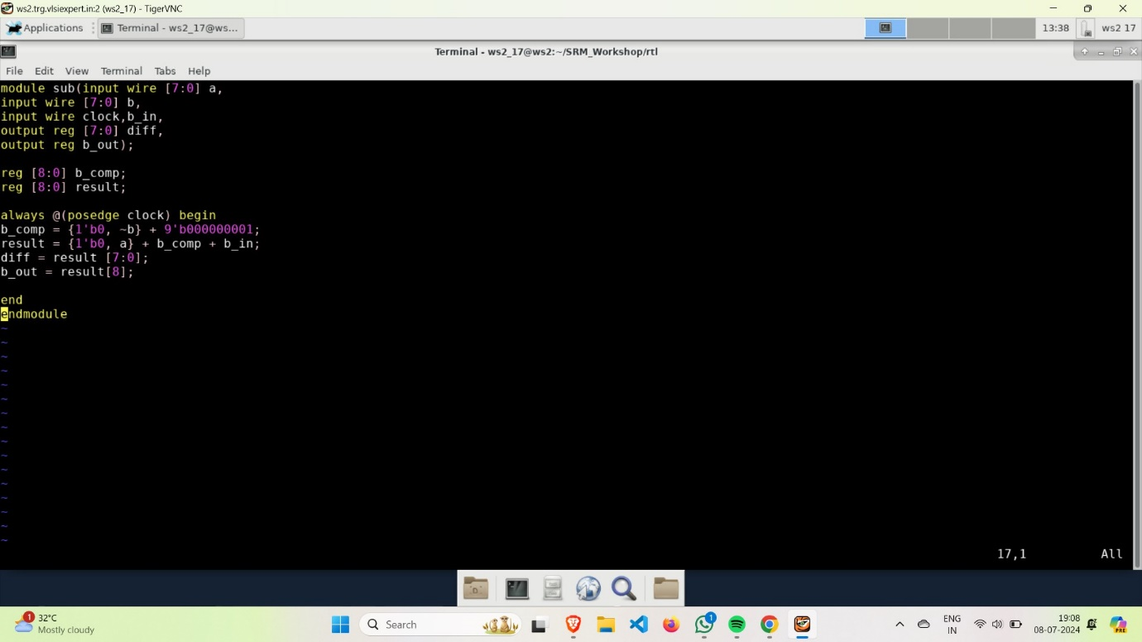

* Now go to rm_setup in DC directory of SRM_Workshop and open the common_setup.tcl and give design name as “sub”.

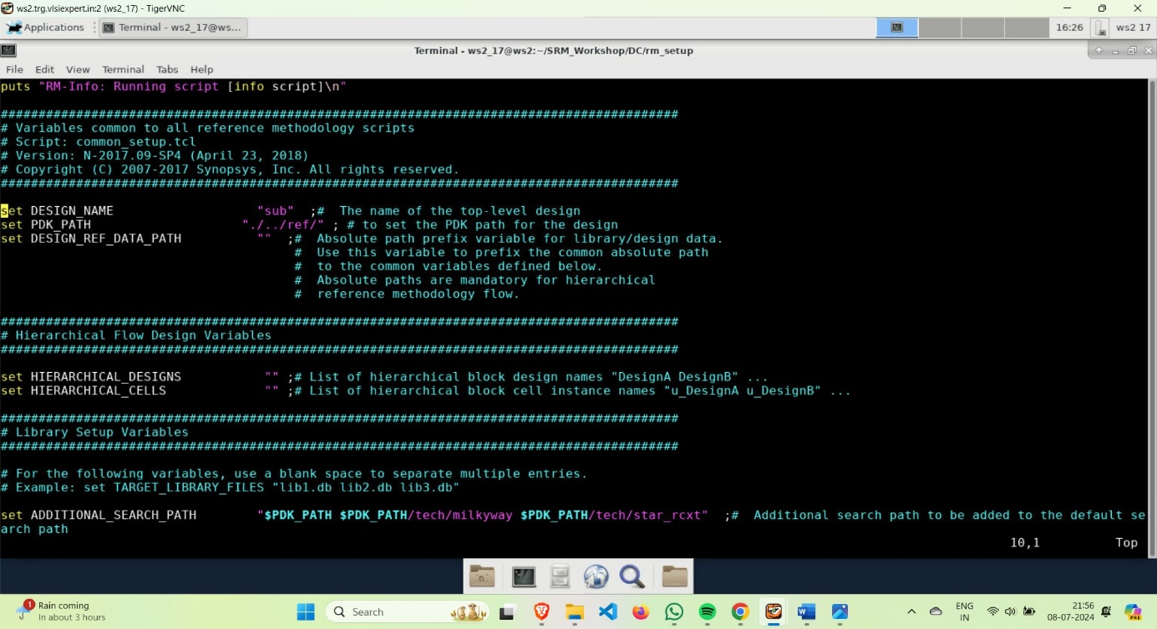

* Now, create a file named “sub.sdc” in Constraints of SRM_workshop directory.
  + - Constraints: Constraints in VLSI design ensure that the physical and electrical characteristics of the chip meet specific performance, power, and area requirements. These include timing constraints, power constraints, physical layout constraints, and signal integrity constraints, all crucial for optimal chip functionality and manufacturability.

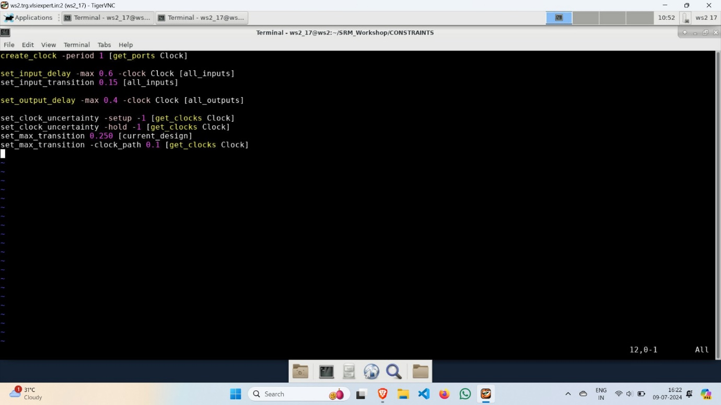

* Now, in one terminal open the run_dc.tcl script and in other invoke dc_shell in DC directory and execute all code lines of run_dc.tcl in dc_shell beginning with start_gui
  + - **start_gui:** It initializes the graphical user interface for design and analysis. Run `start_gui` from the command line in your VLSI design environment to open the GUI and access tools for design, simulation, and verification.

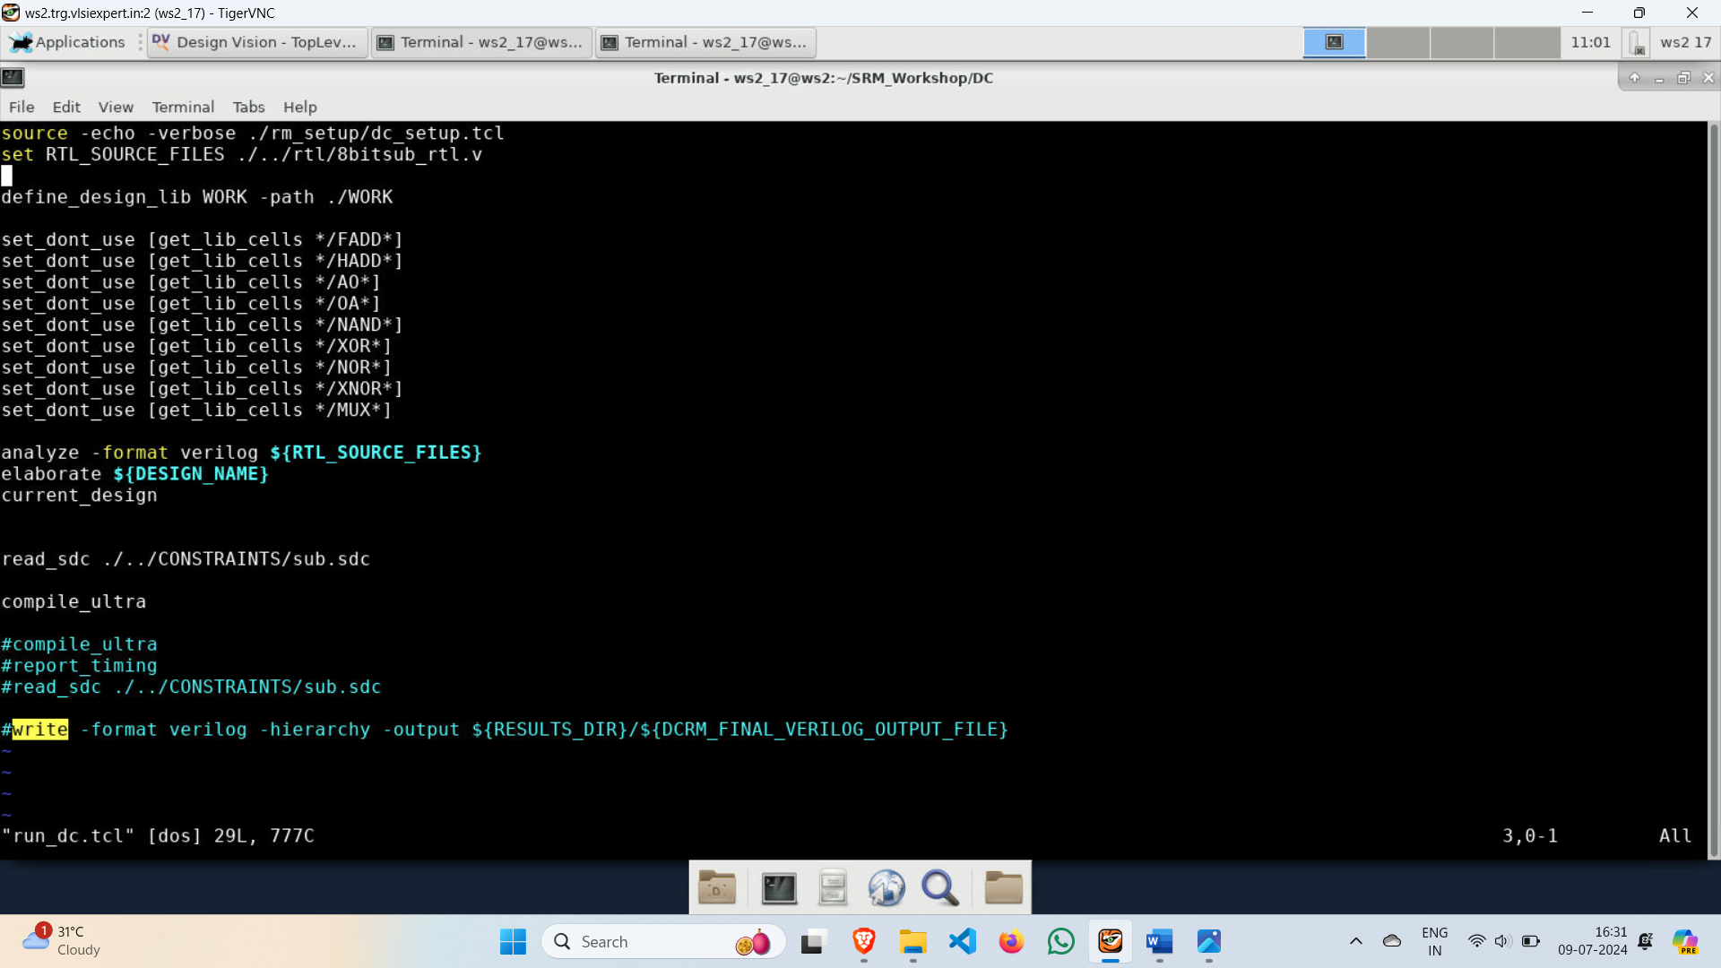

* Now, go to Design Vision to see the block diagram and gate level diagram of 8-Bit Subtractor.

**Block Diagram of 8-Bit Subtractor**

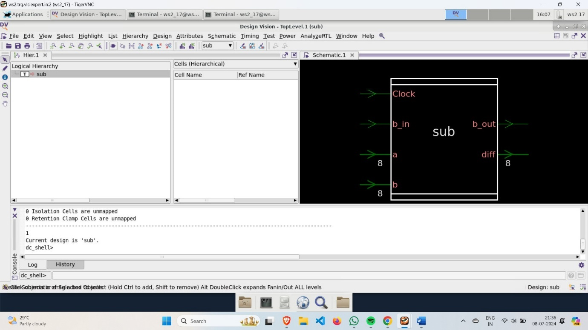

**Gate Level Diagram of 8-Bit Subtractor**

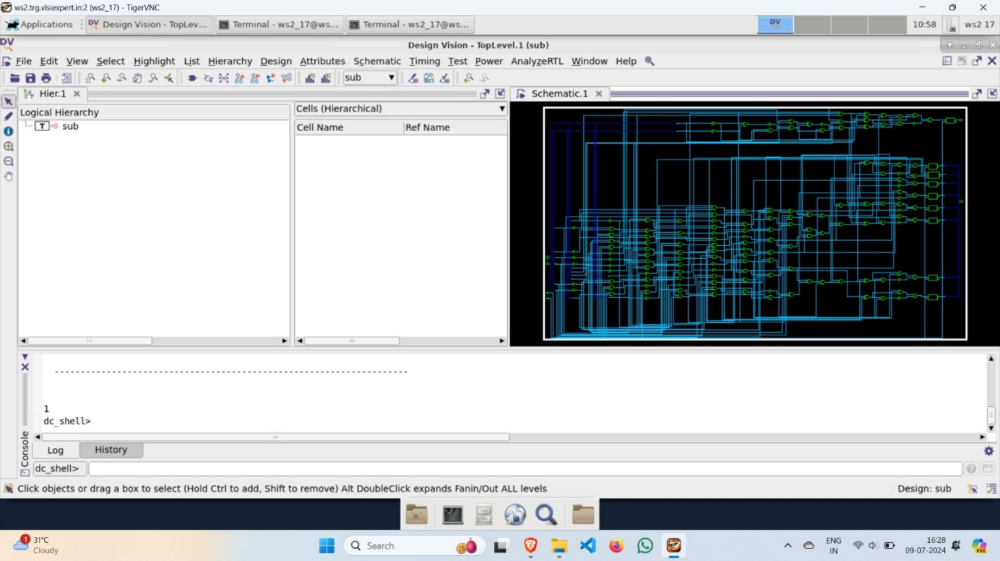

* Now, execute the report_qor 🡪 QOR (Quality of Results) in VLSI (Very-Large-Scale Integration) refers to metrics used to evaluate the efficiency and effectiveness of a design, including performance, power consumption, area, and timing. It is crucial for optimizing design iterations and ensuring the final product meets the desired specifications and constraints.

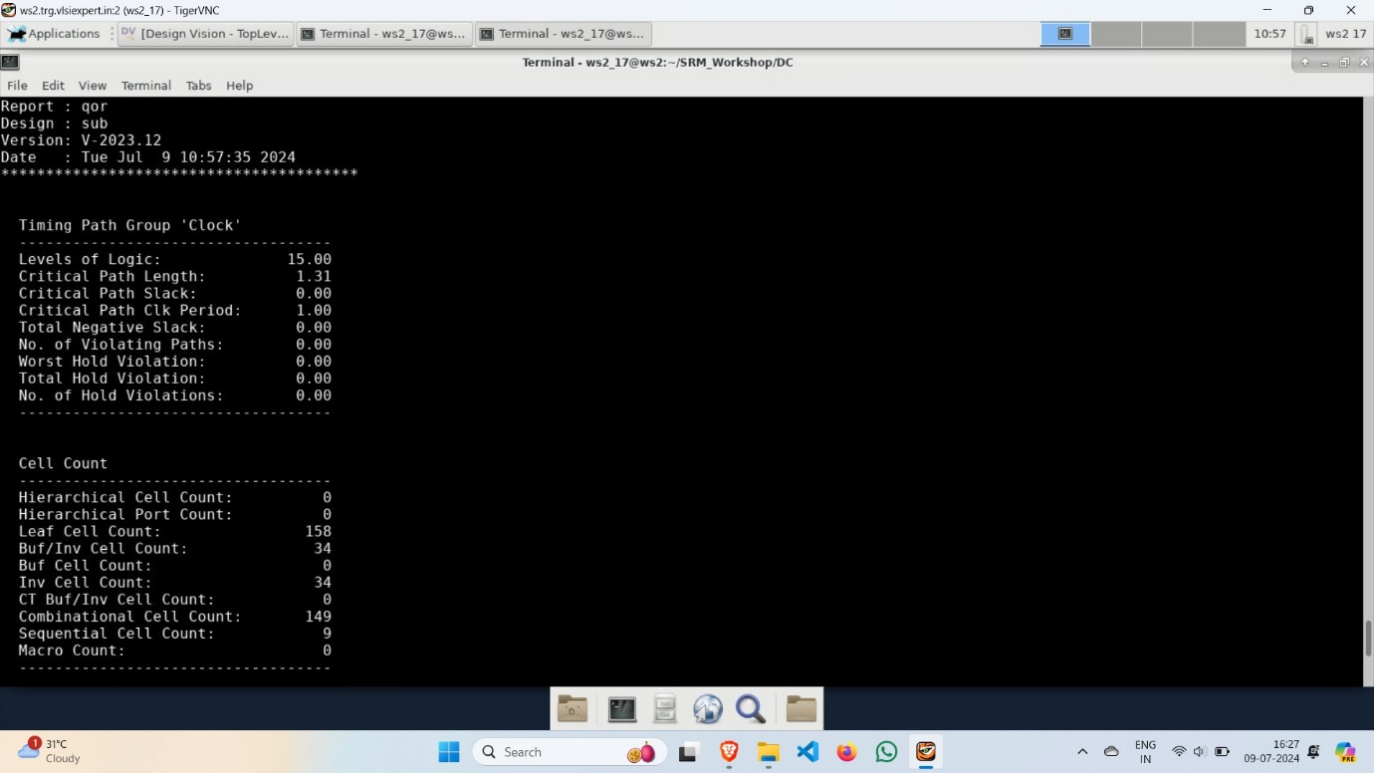

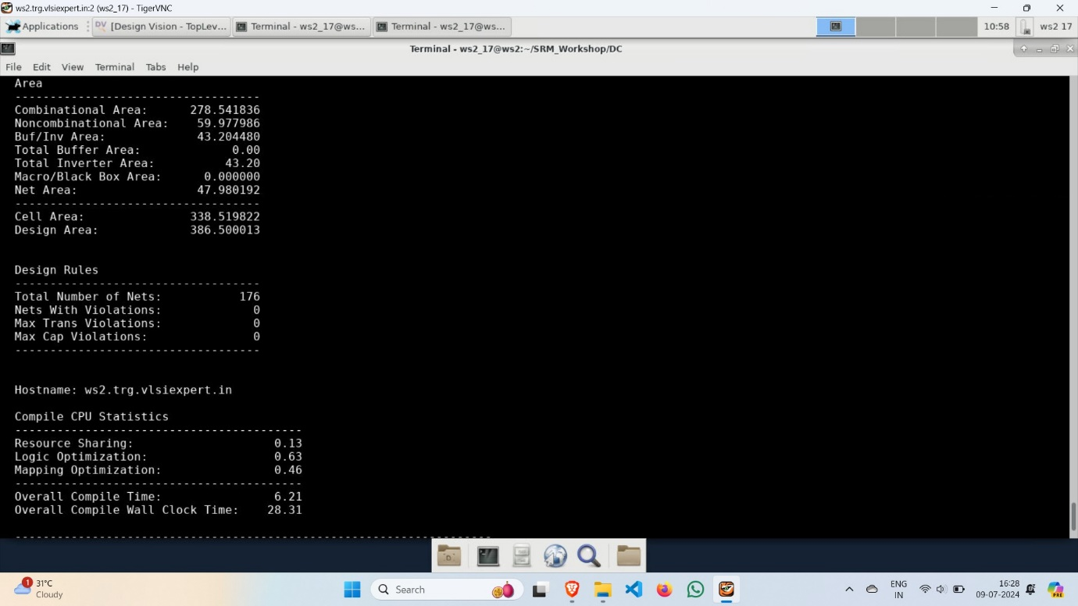

* Now, execute the report_timing 🡪 Report timing involves analysing and verifying the timing of digital circuits to ensure they meet the required performance and timing constraints. This process includes checking setup and hold times, clock skew, and propagation delays to optimize the design for speed and reliability.

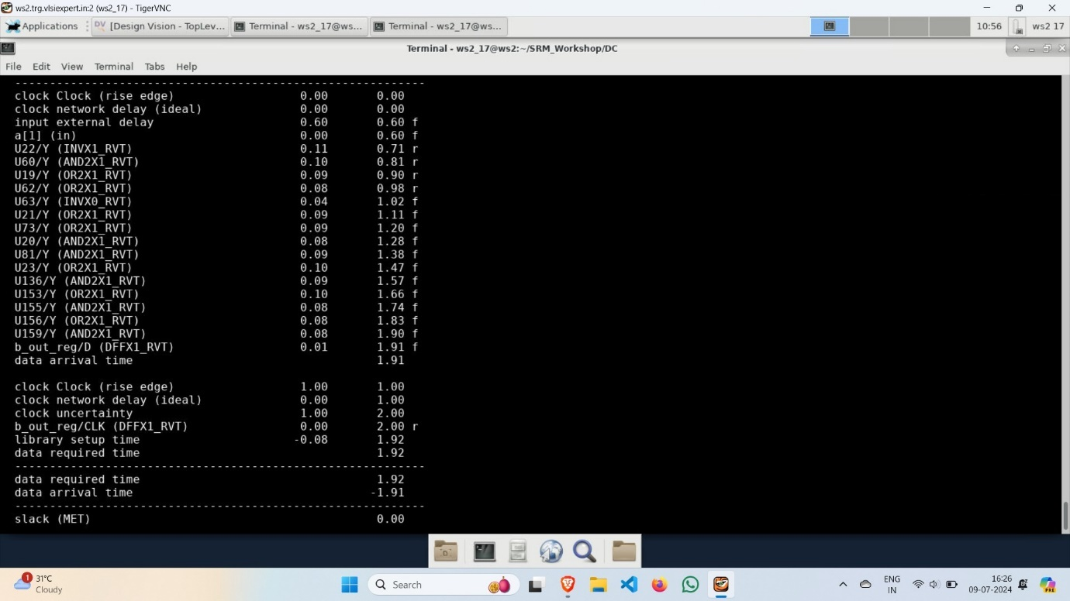

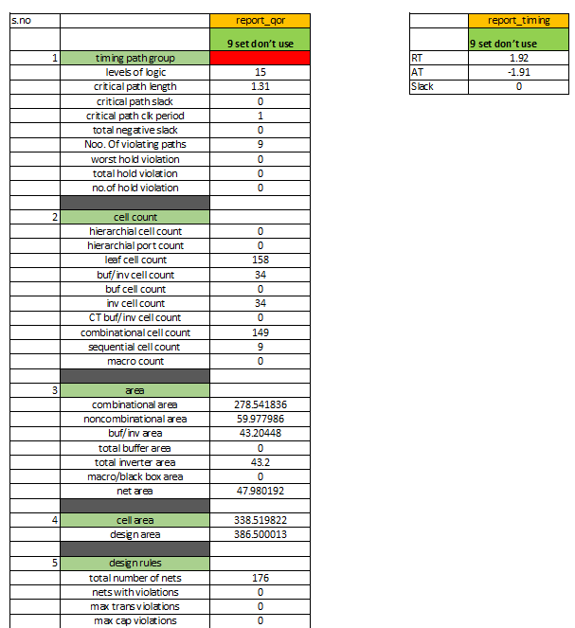

* Now, save the gate level mapped netlist as “sub.mapped.v” in results directory of DC directory.

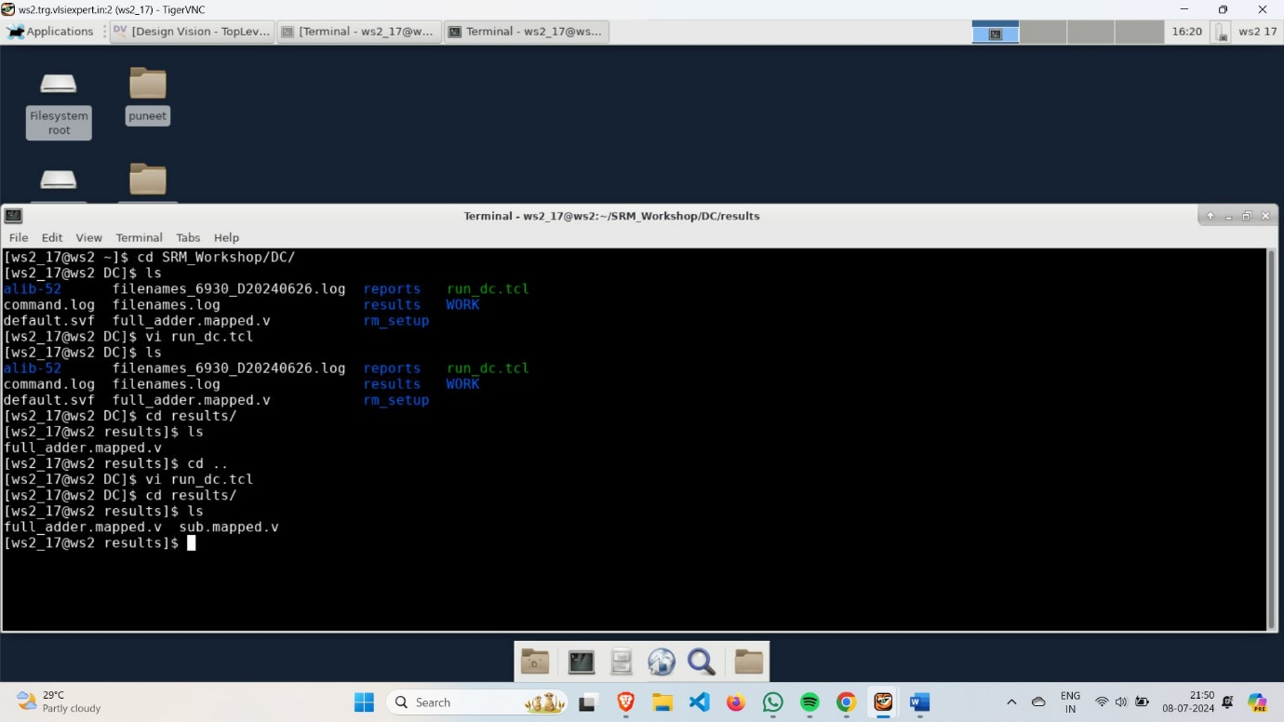

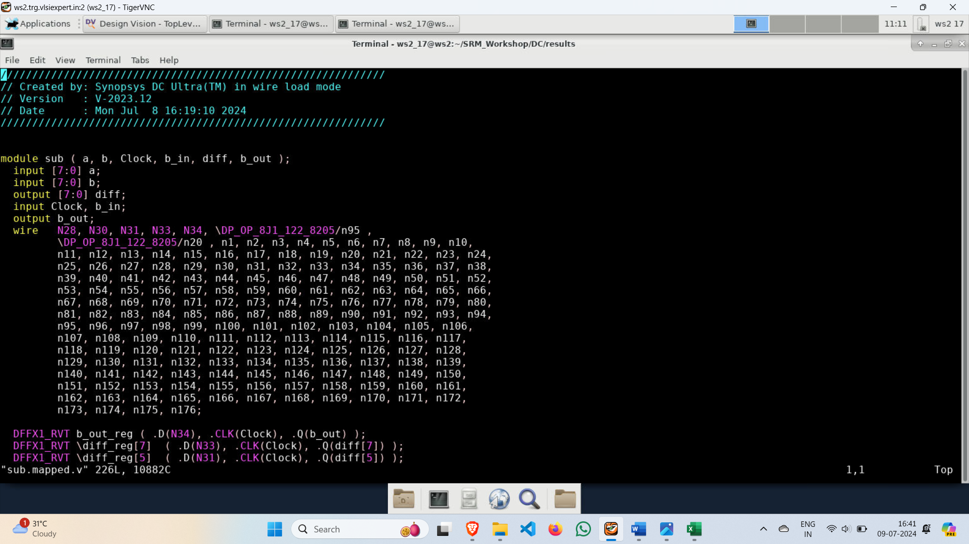

**Floorplan**

* A floorplan is a blueprint that arranges the placement of functional blocks (such as processors, memory, and I/O pads) on a chip to optimize performance, power consumption, and area. It involves defining the size and shape of each block and their locations, ensuring efficient interconnections and minimizing delays.
* Open floorplan.tcl file in scripts directory of ICCII directory in one terminal and in other terminal invoke icc2_shell and execute all line code of floorplan.tcl beginning with start_gui
  + - Initialize the floorplan with 60% core utilization and coincident boundary with offset of {1 1}.
    - Create hard type placement blockage.
    - Place input pins on side 1 and output pins on side 3.
    - Create placement with high effort.
    - Give library name as SUB_LIB_1 and block name as 8bit_sub.

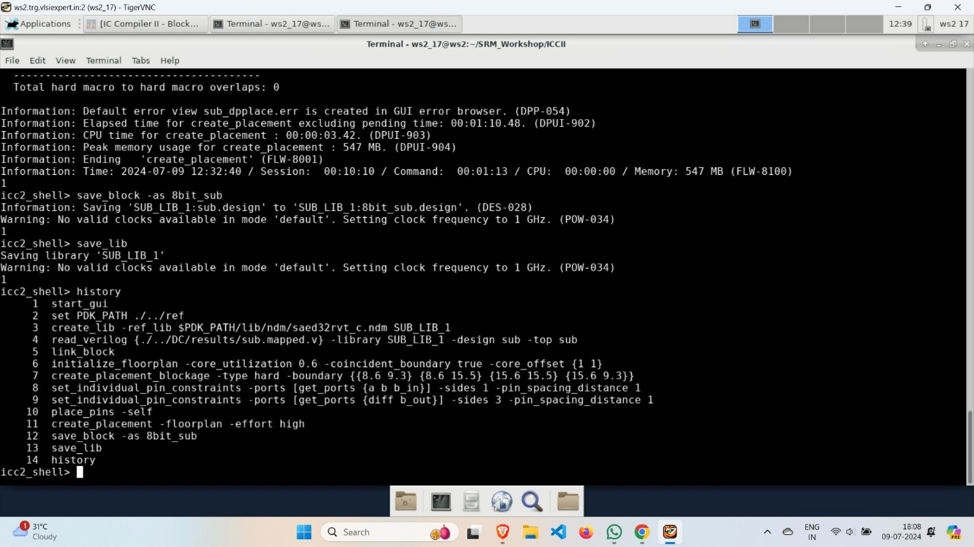

* Now, go to IC Compiler II to see the block diagram of the floorplan.

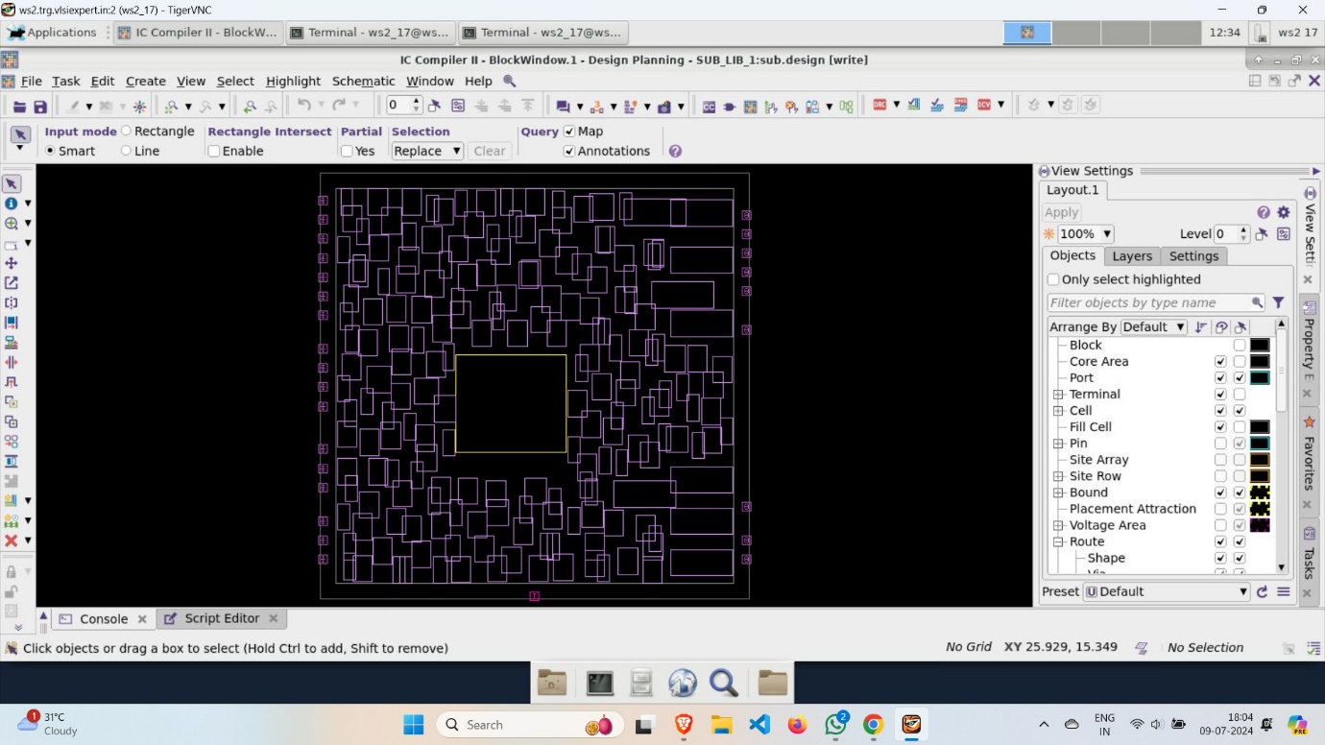

* report_qor

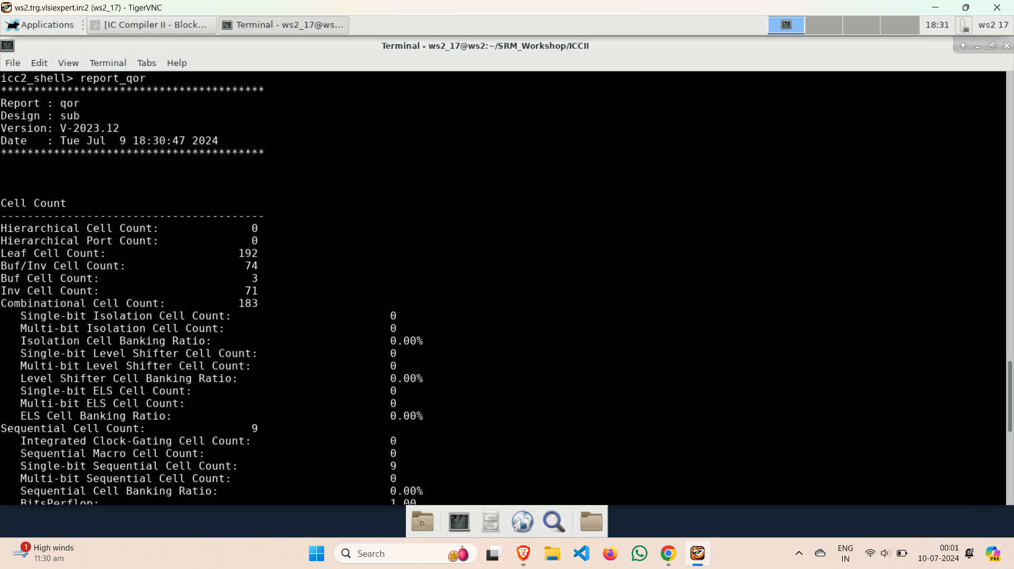

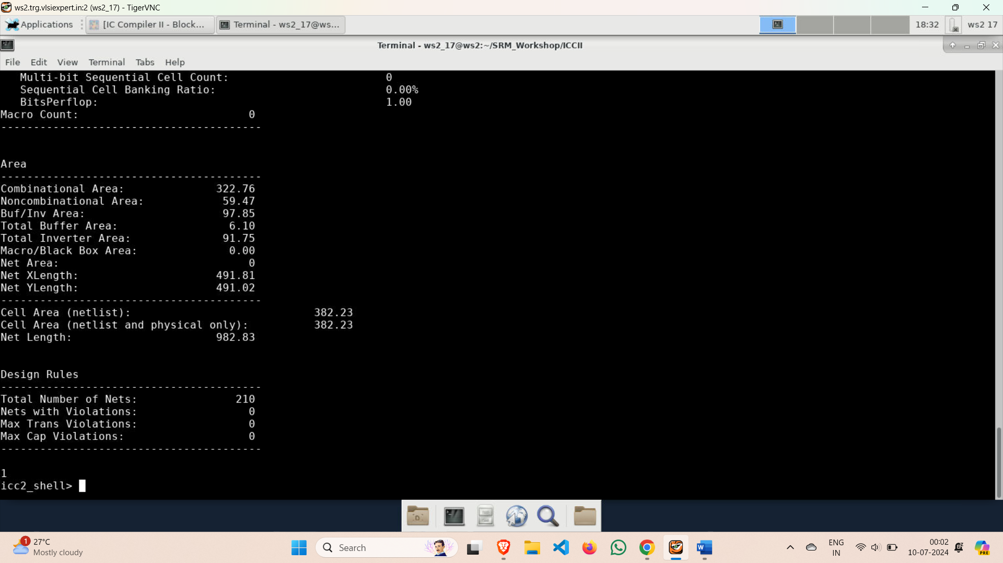

**Powerplan**

* A Powerplan is the layout and distribution of power and ground networks to ensure reliable and efficient delivery of power to all parts of the chip. This involves designing power grids, power rings, and decoupling capacitors to minimize voltage drop and noise, ensuring stable operation of the integrated circuits.
* Invoke the icc2_shell in ICCII directory and write the powerplan_tcl code in icc2_shell beginning with start_gui in the same block and library as of floorplan.

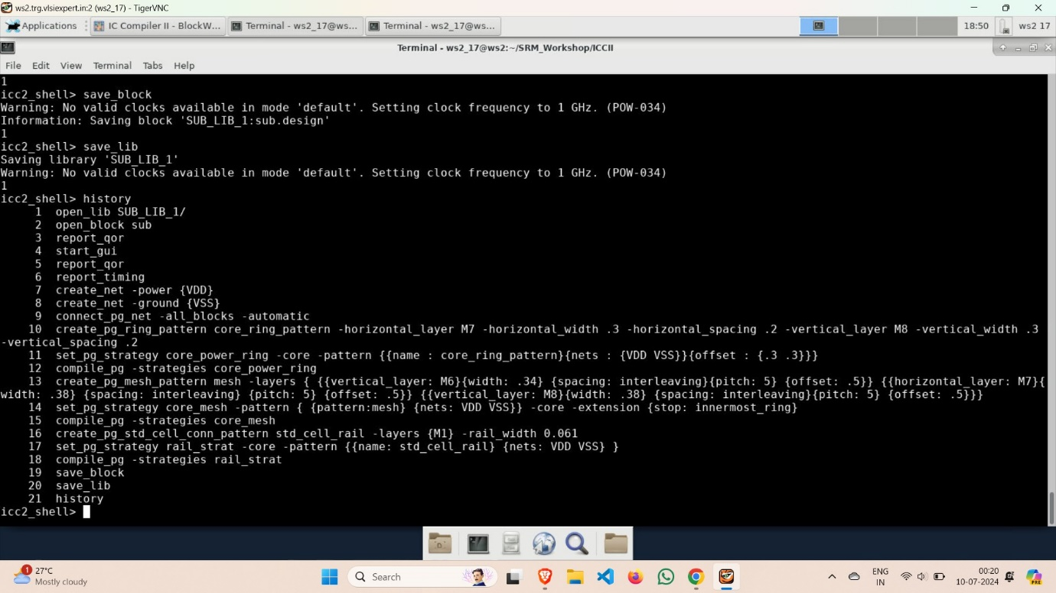

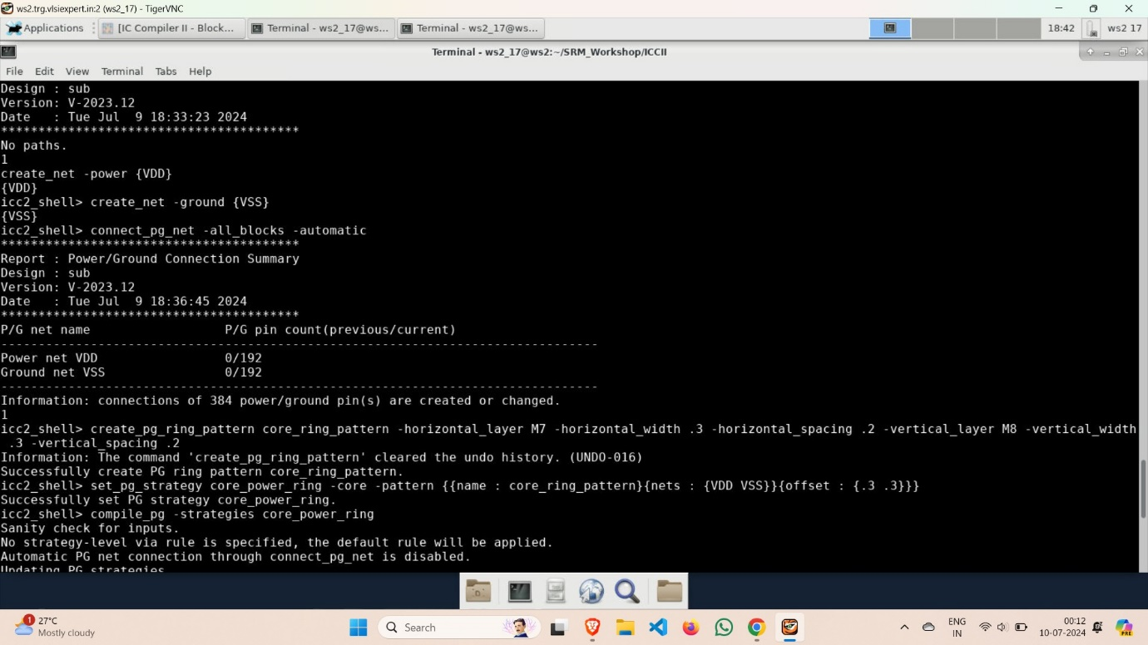

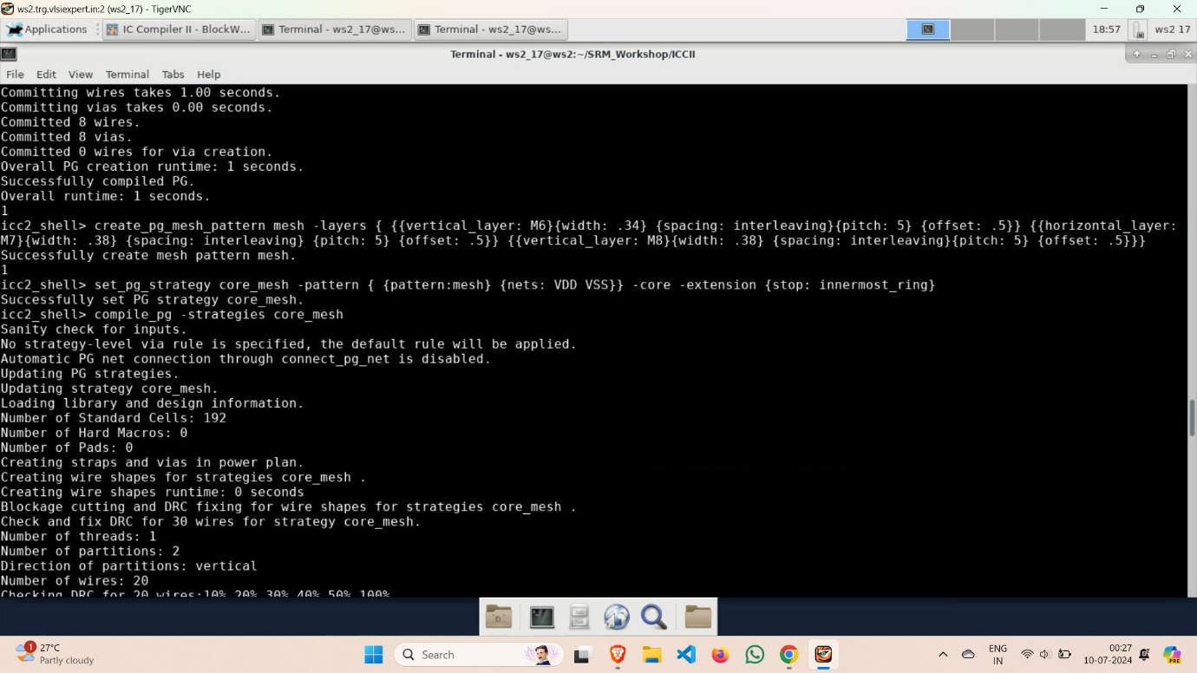

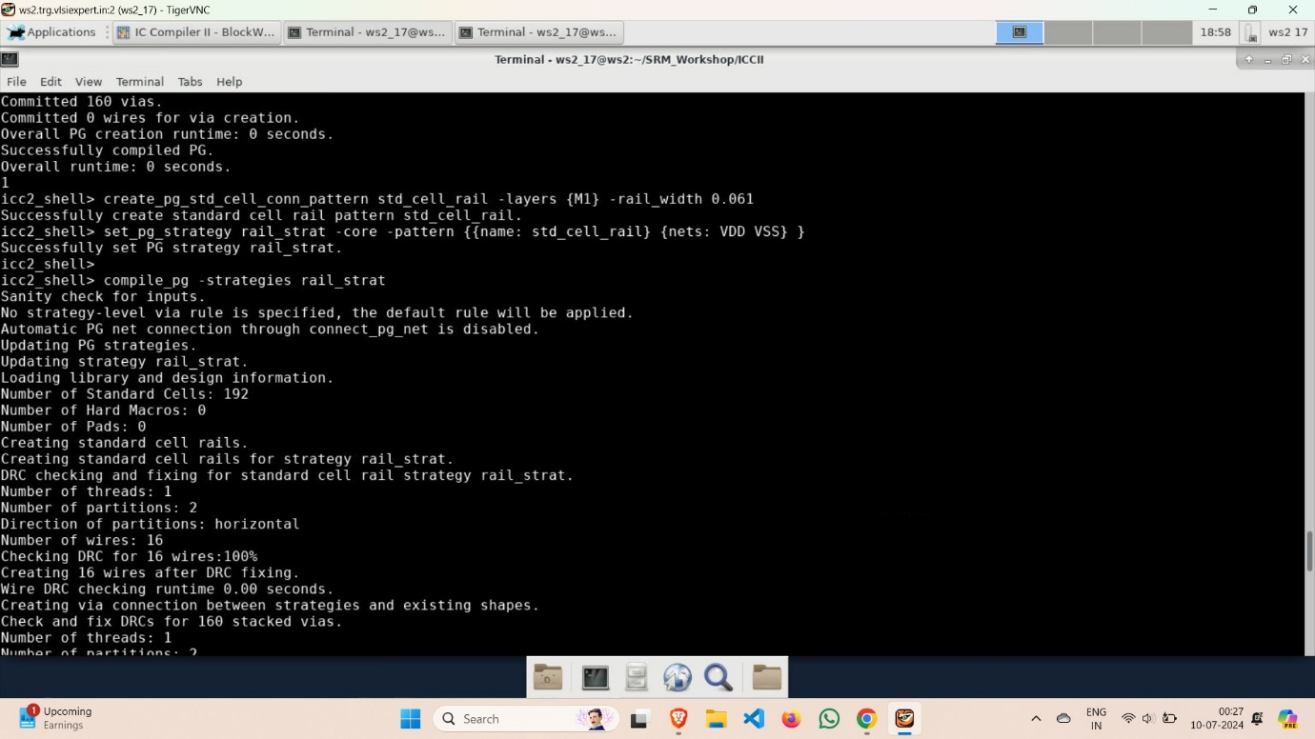

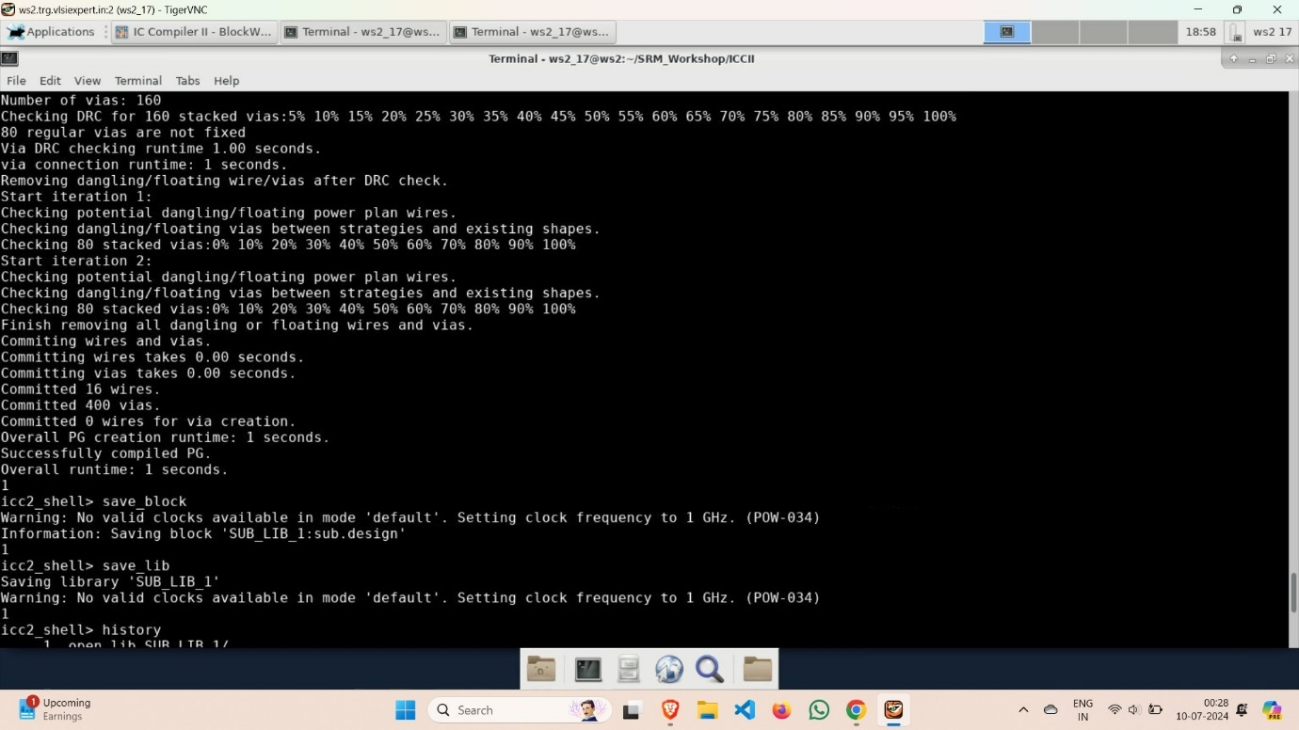

* Now, go to IC Compiler II to see the output of the Powerplan.

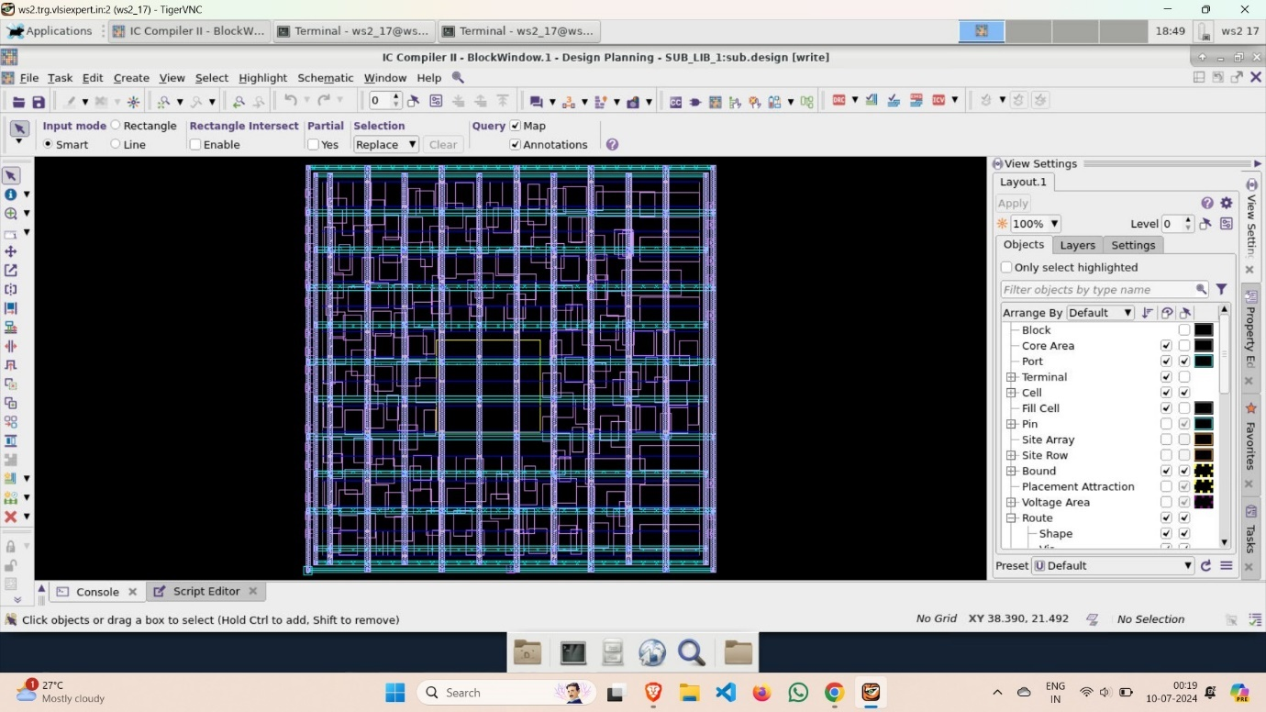

**Placement**

* Placement refers to the process of arranging the various components (standard cells, macros, etc.) on a chip in an optimal manner to meet design specifications and performance goals. It ensures that the components are positioned to minimize interconnect delays, power consumption, and area while maximizing the chip's overall performance and manufacturability.
* Start typing the code of placement just after the completion of the Powerplan is completed and save the block as 8bitsub_placement.

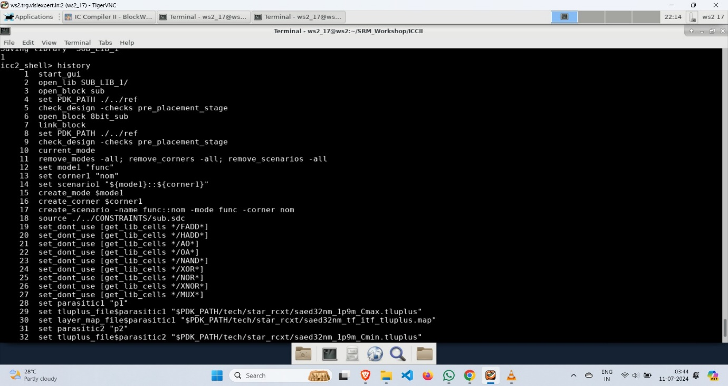

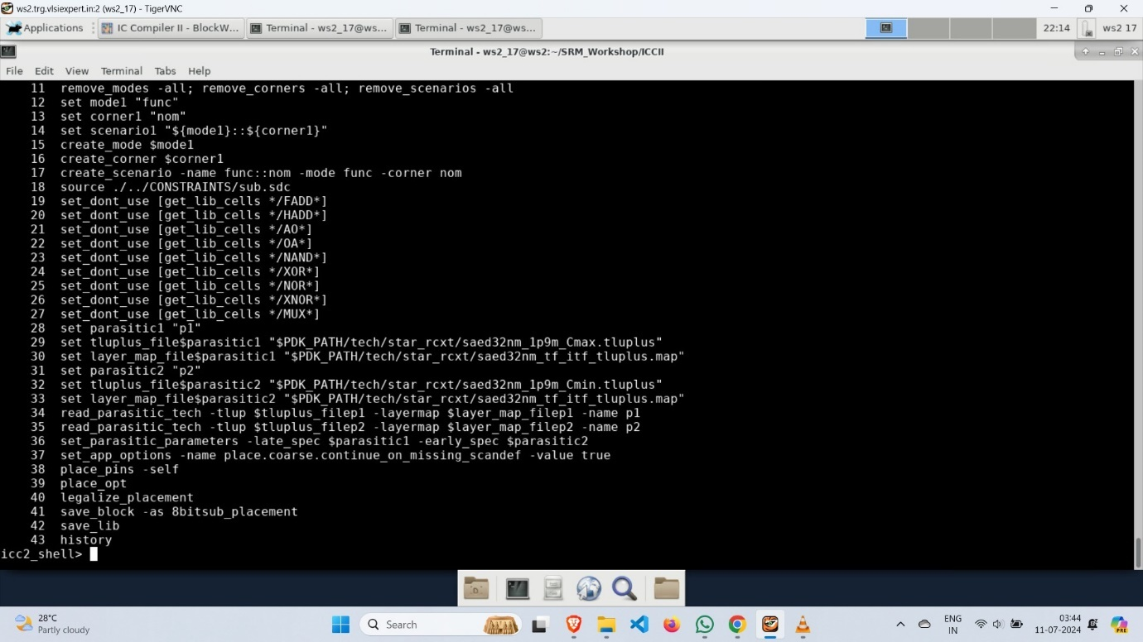

* **place_opt**🡪 Place Optimization is the process of arranging standard cells and macros on a chip layout, followed by optimizing their positions to minimize timing delays, power consumption, and area while meeting design constraints. This step ensures efficient interconnection of components and overall performance of the integrated circuit.

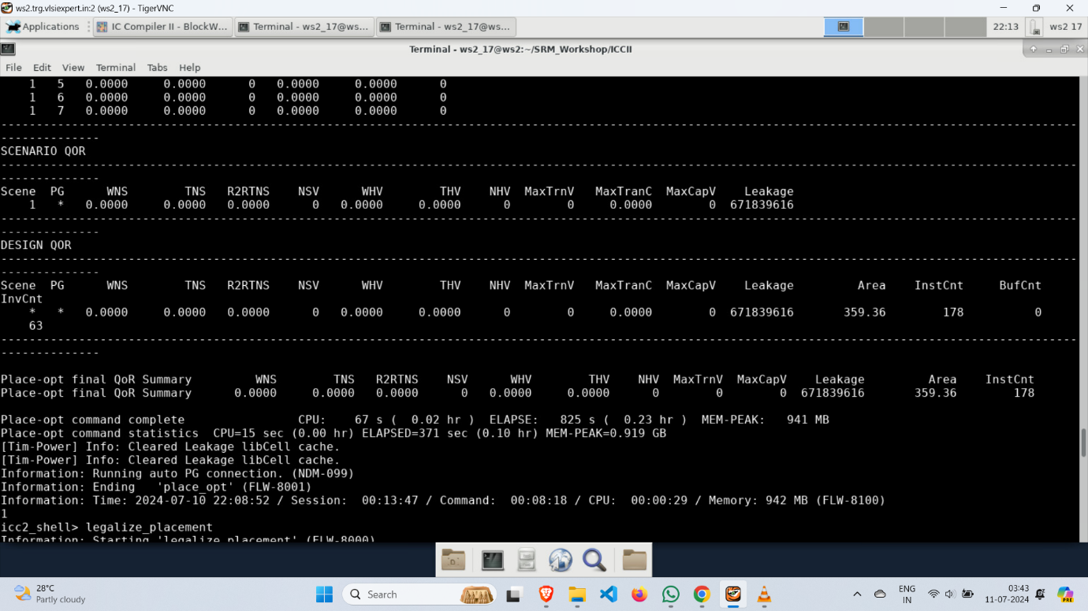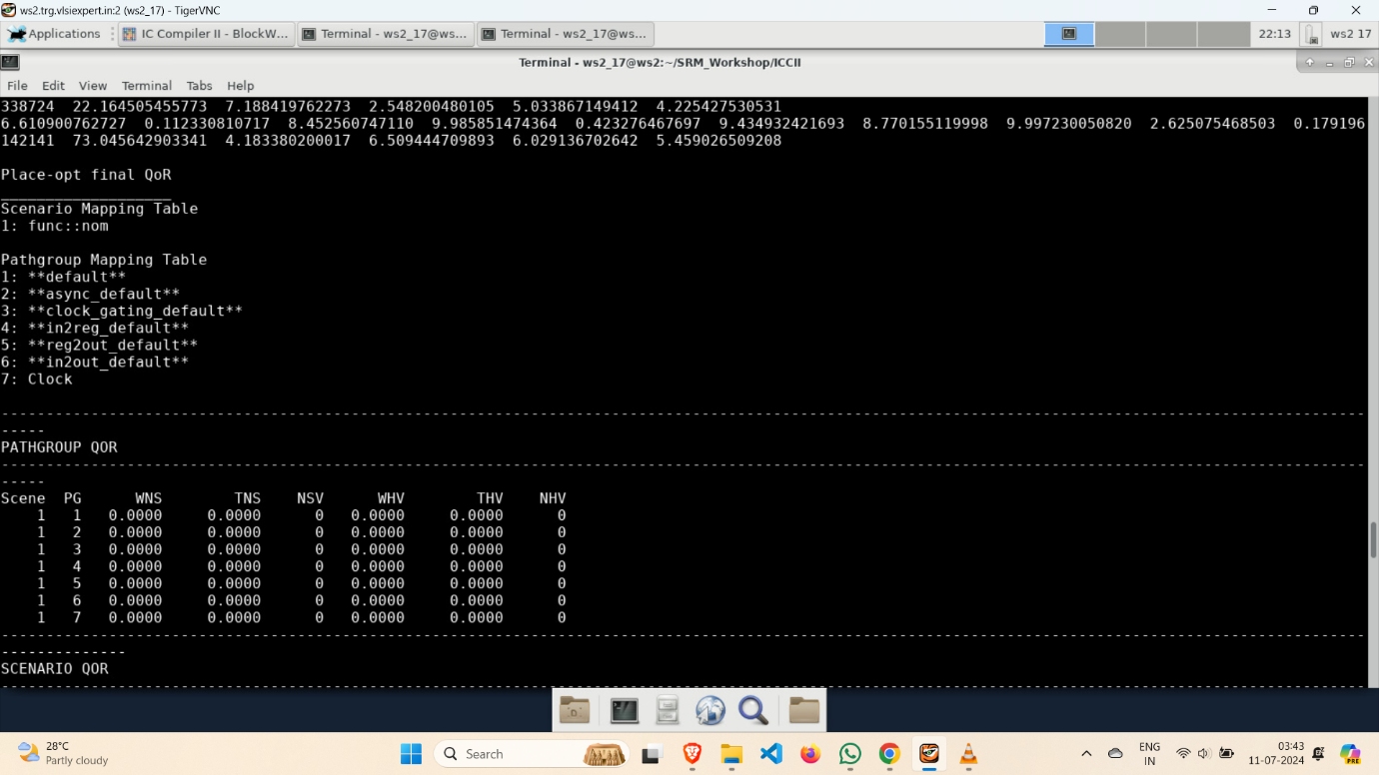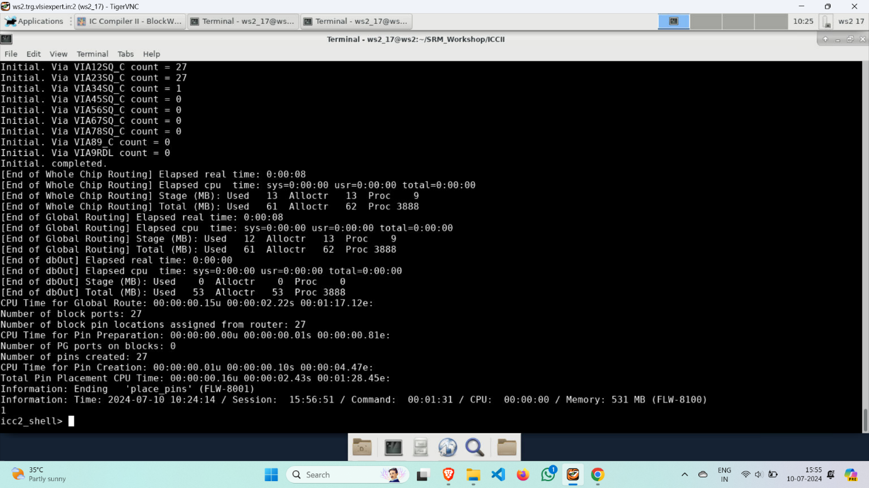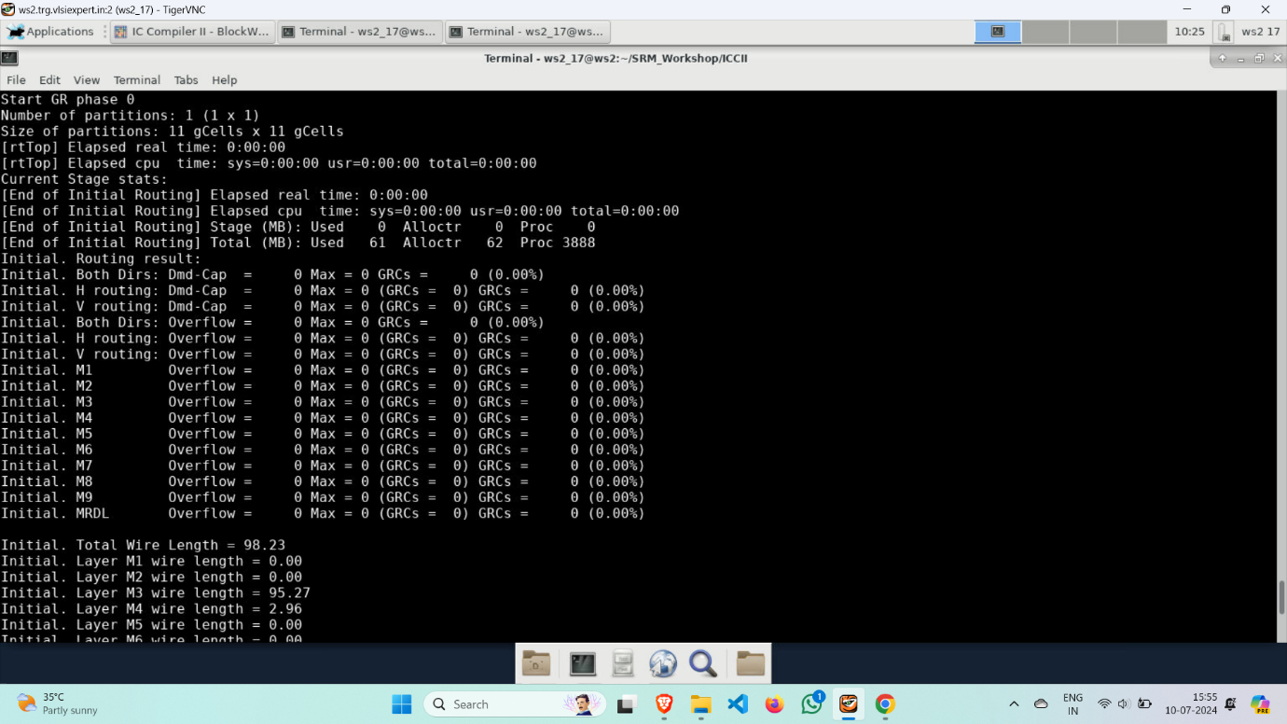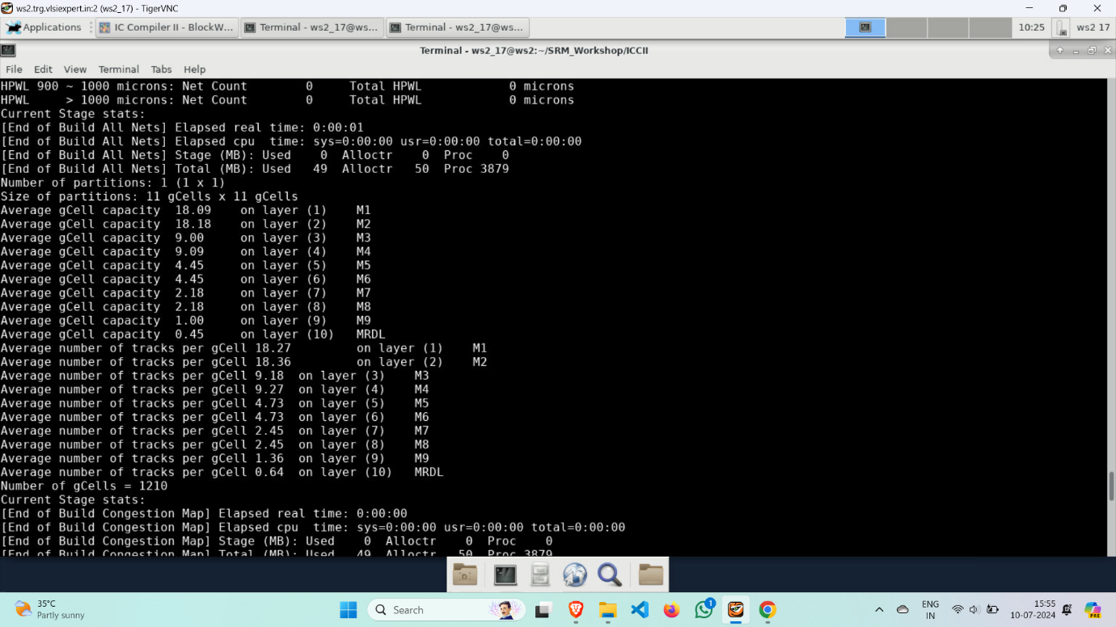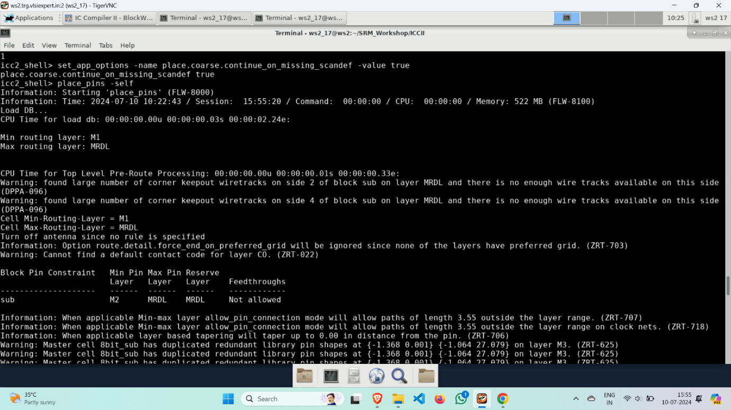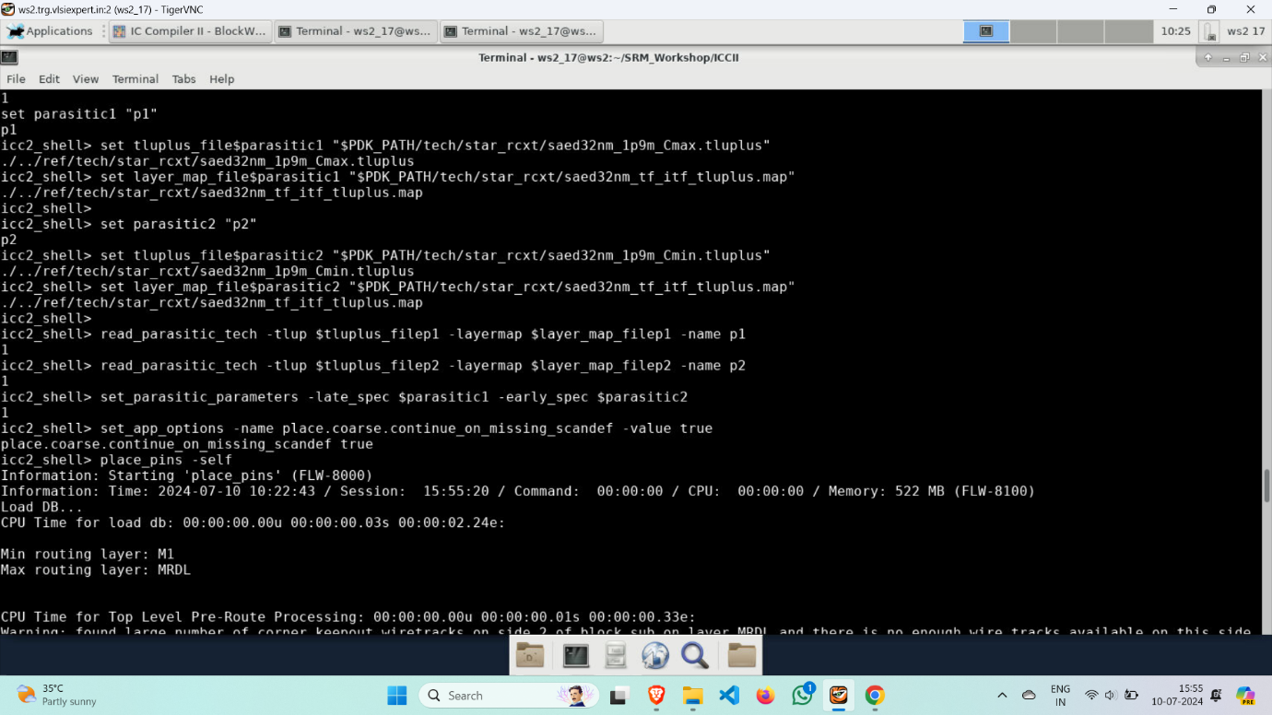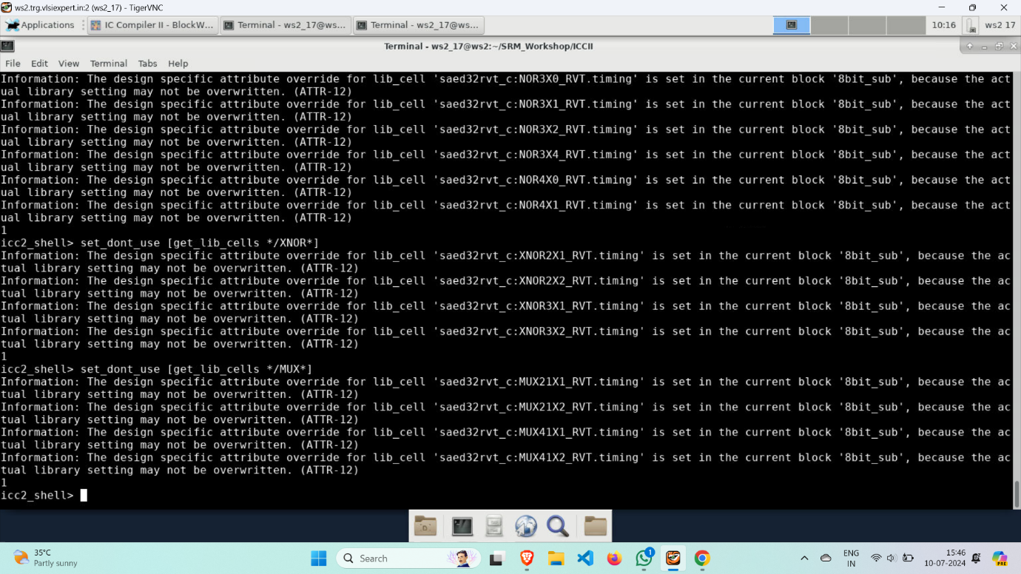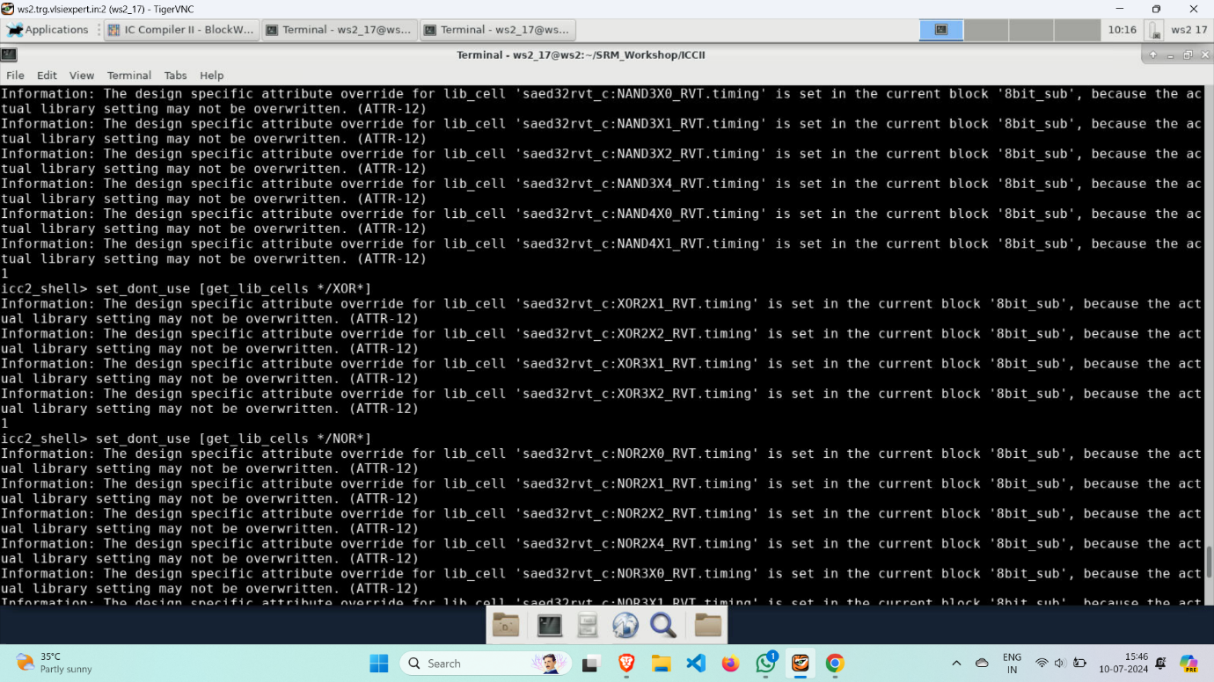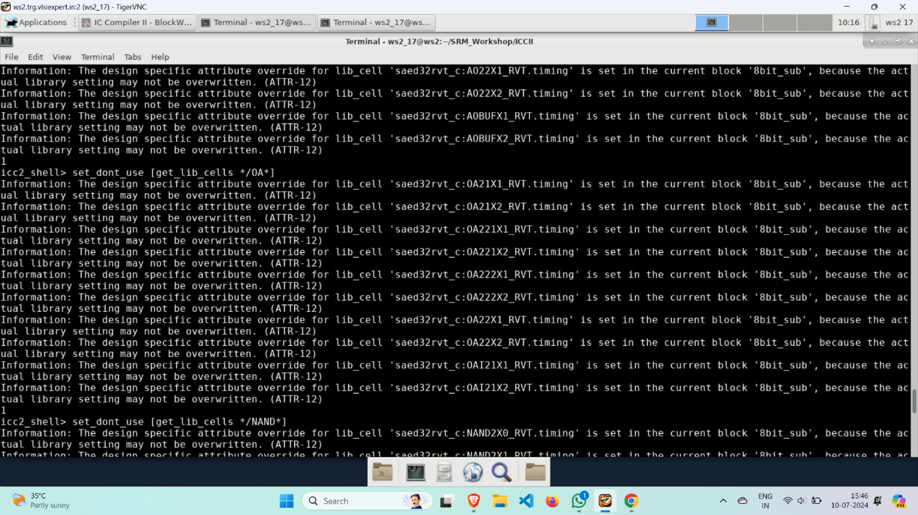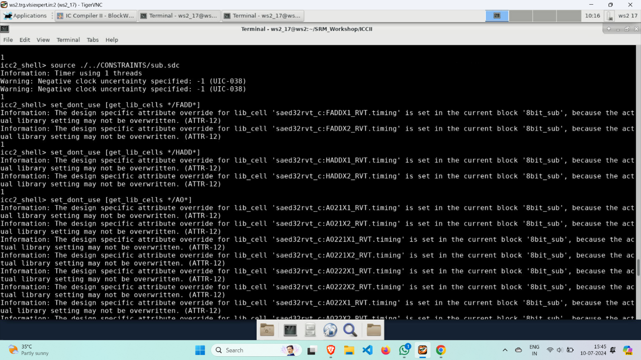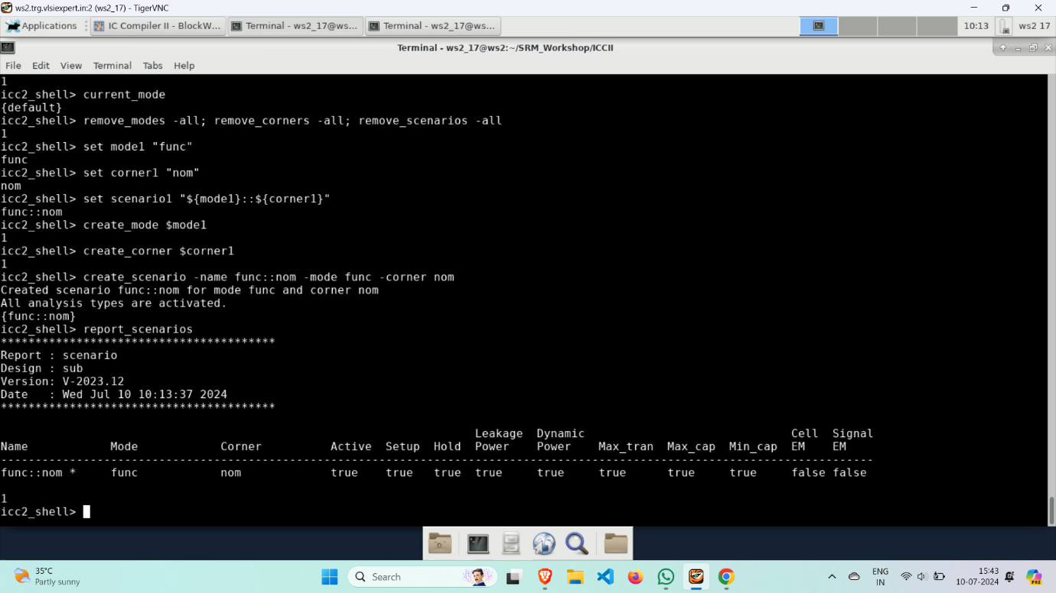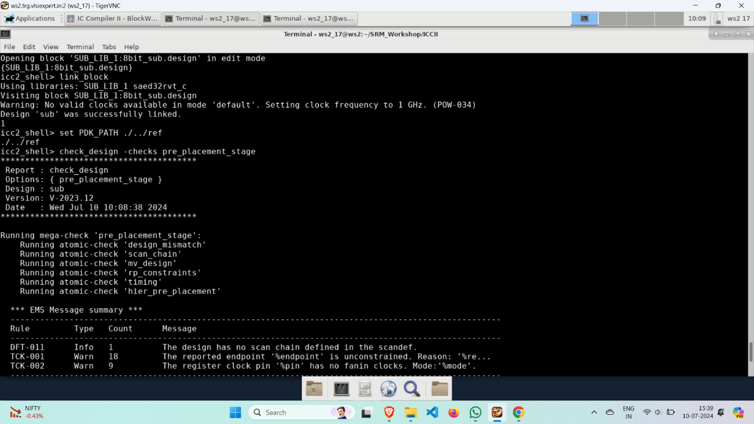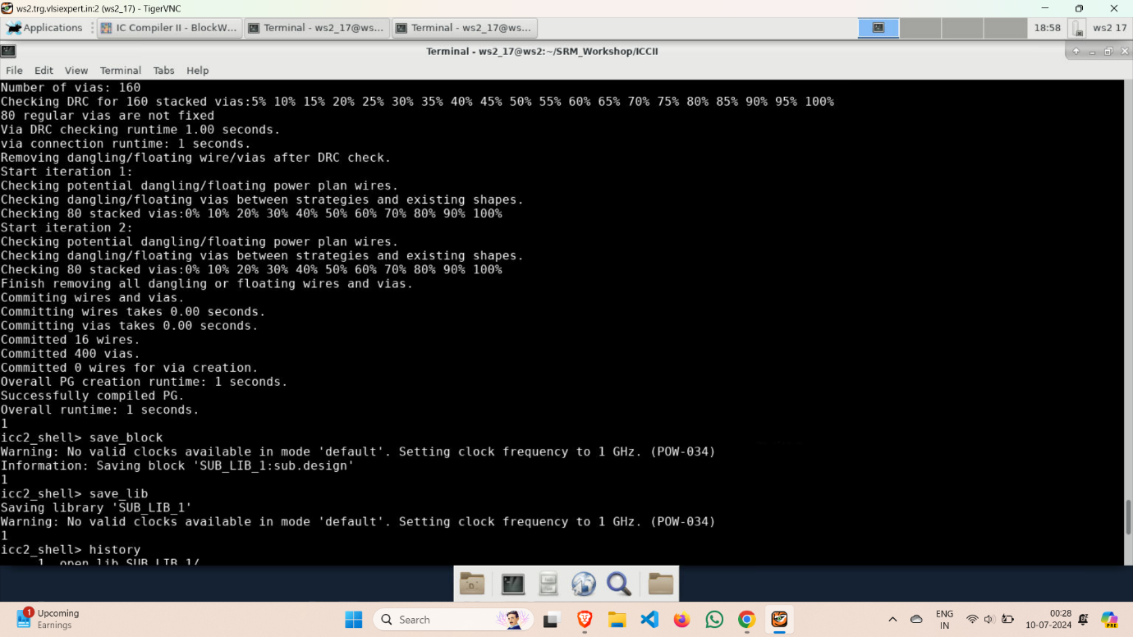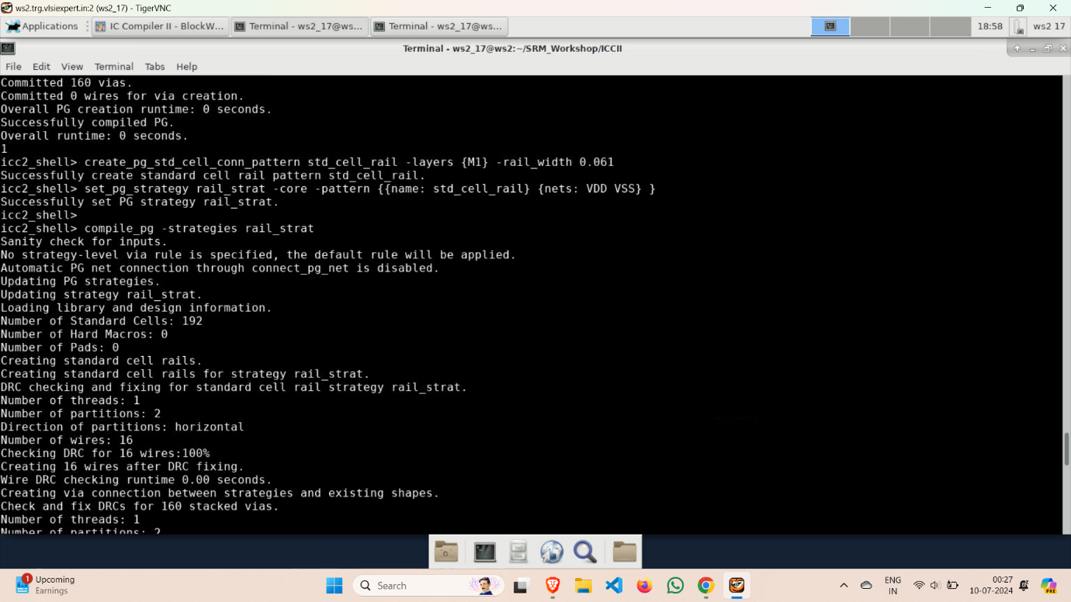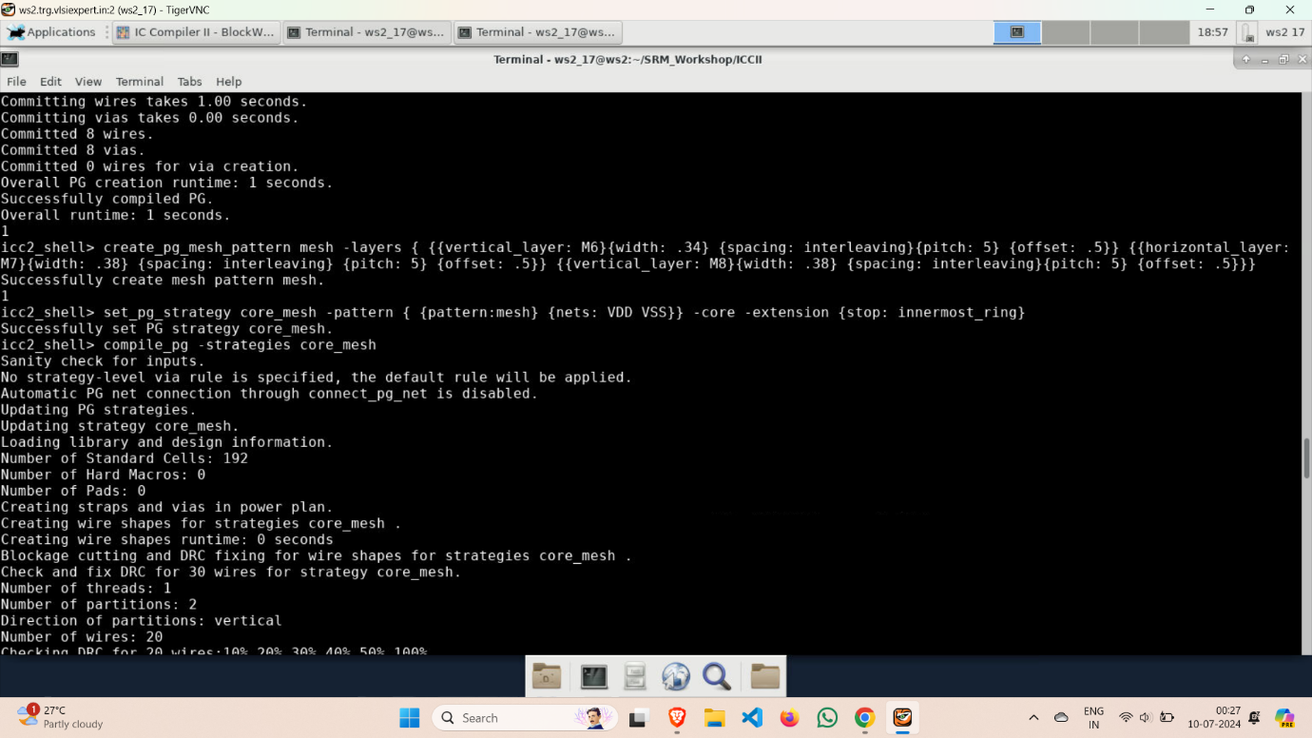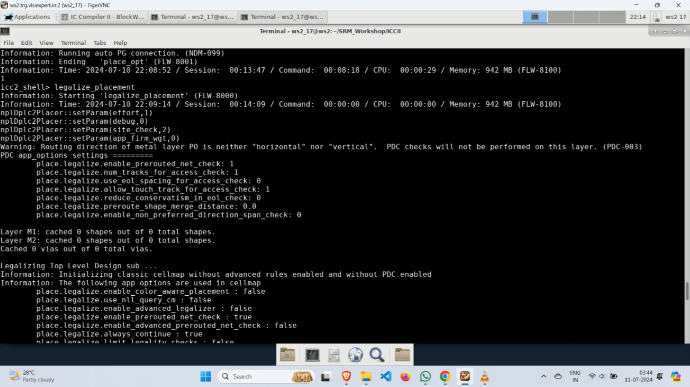

* Now, go to IC Compiler II to see the output of the placement.

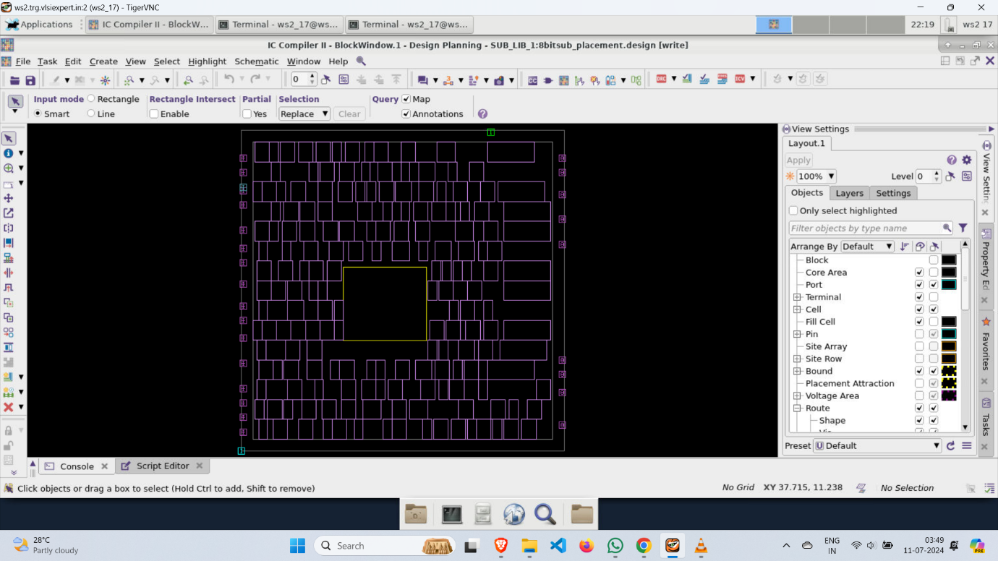

* **report_design**🡪 generates a detailed summary of the design, including metrics like timing, area, power, and connectivity. This report aids in verifying that the design meets specified requirements and helps identify potential issues for further optimization.

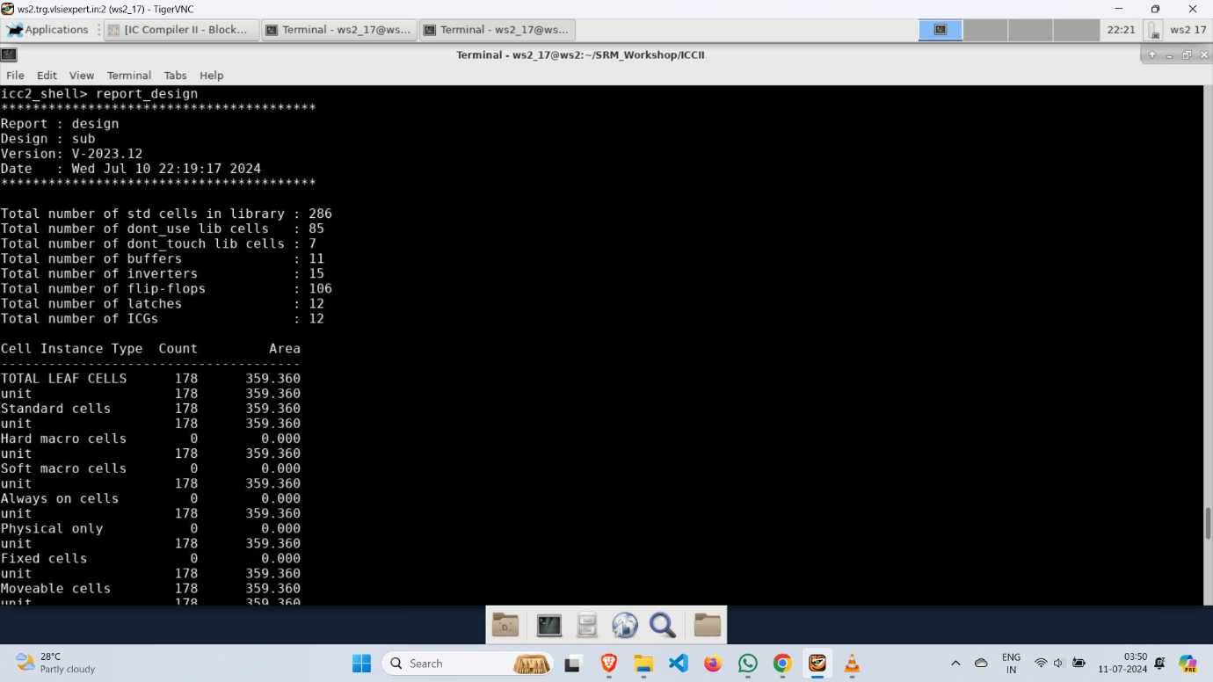

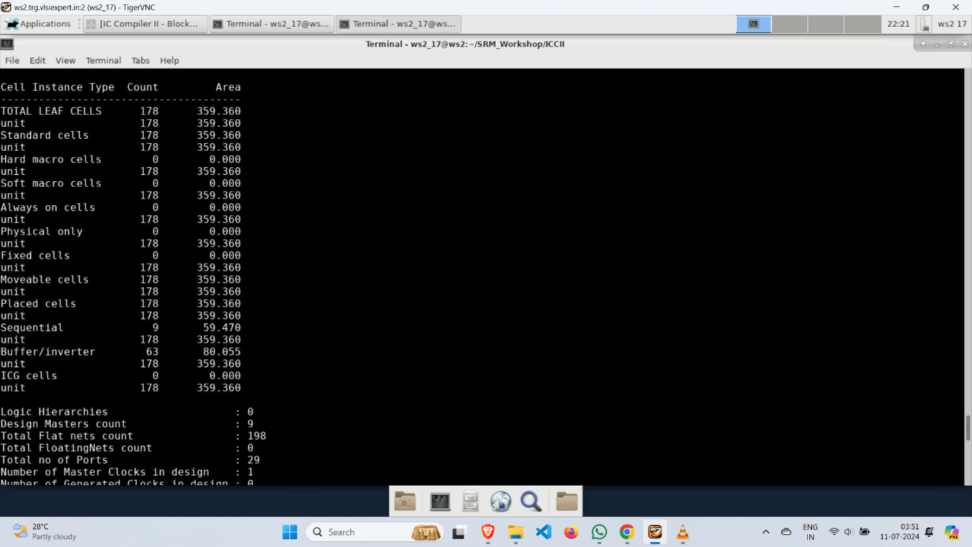

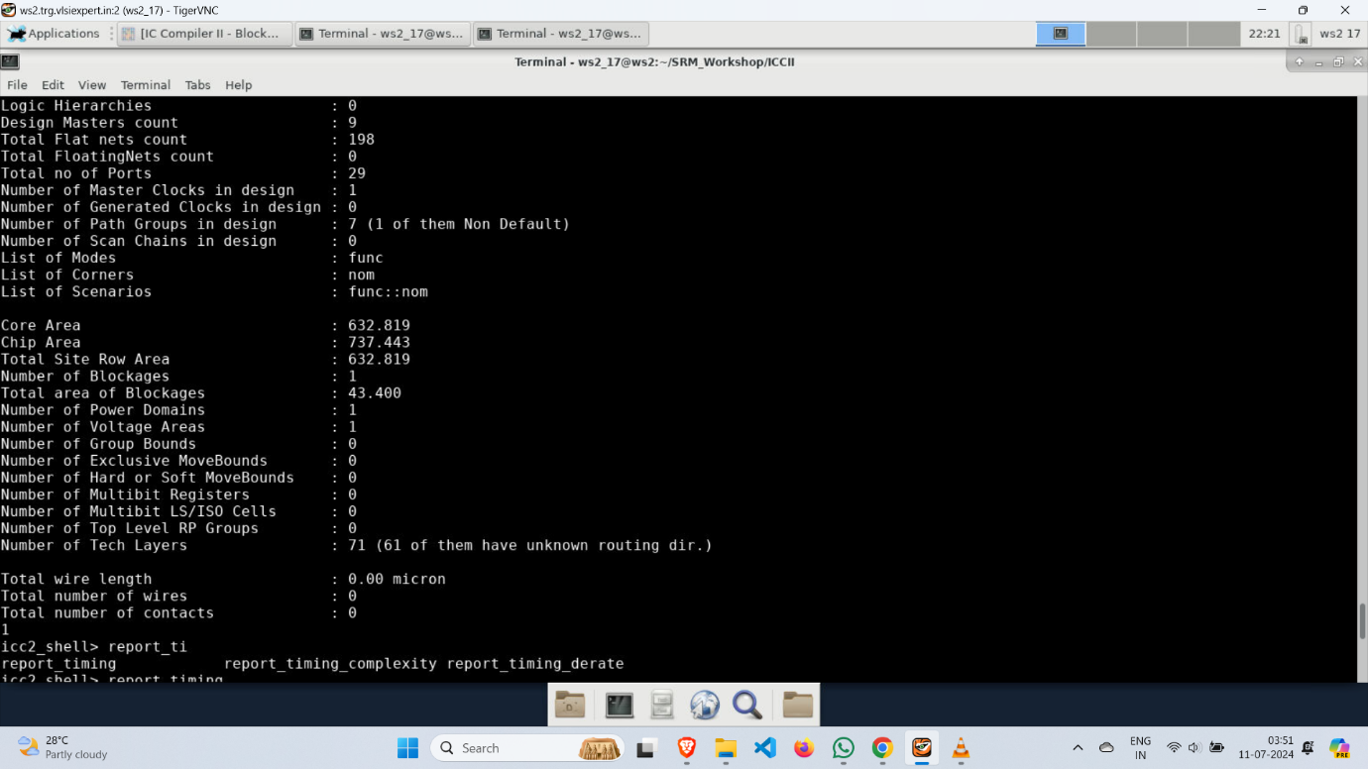

* report_timing

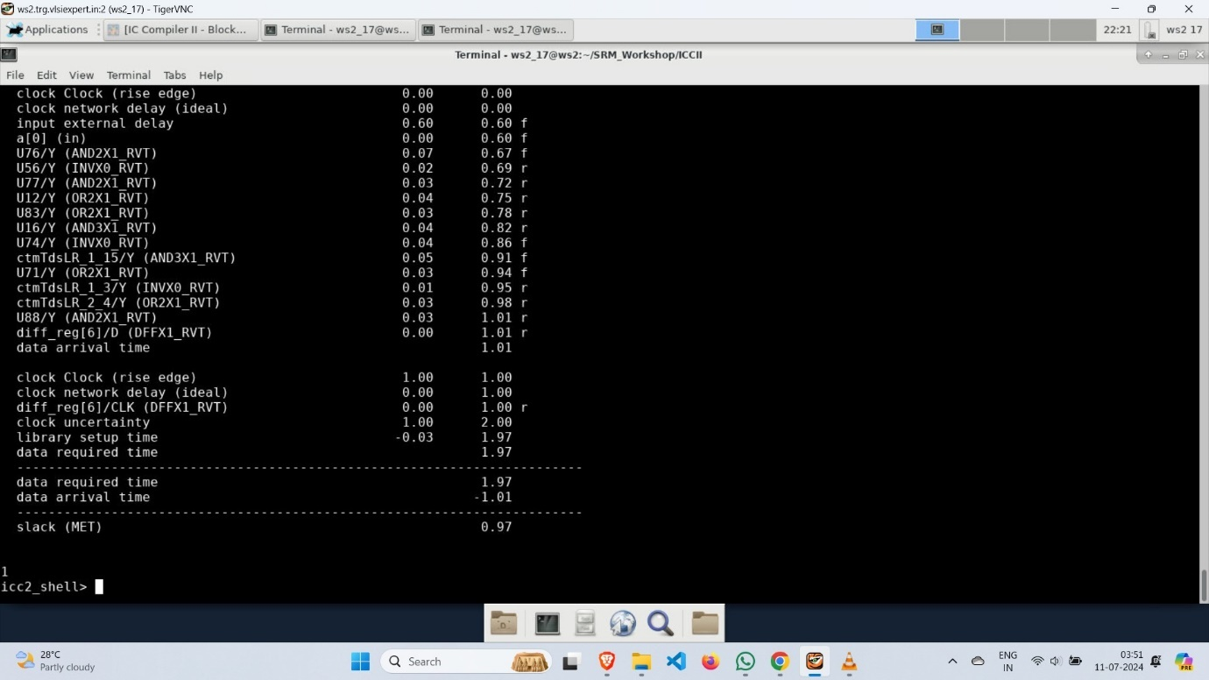

**Clock Tree Synthesis(CTS)**

* Clock Tree Synthesis (CTS) involves the design and optimization of the clock distribution network to ensure minimal skew and latency, thereby synchronizing the timing of all sequential elements in an integrated circuit. This process uses algorithms to balance the clock tree, ensuring signal integrity and performance across the chip.
* After the completion of the placement start the clock tree synthesis and execute all codes of CTS and save the block as 8bitsub_cts_CCD.

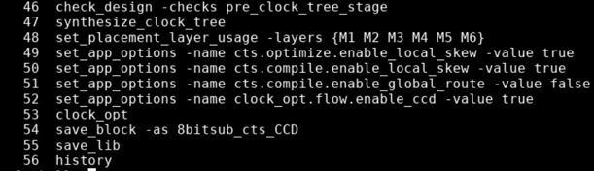

* **clock_opt**🡪 Clock optimization focuses on improving the performance of the clock distribution network by reducing clock skew, minimizing power consumption, and ensuring timing constraints are met. Techniques such as clock gating, useful skew, and buffer insertion are employed to enhance the efficiency and reliability of the clock signal throughout the integrated circuit.

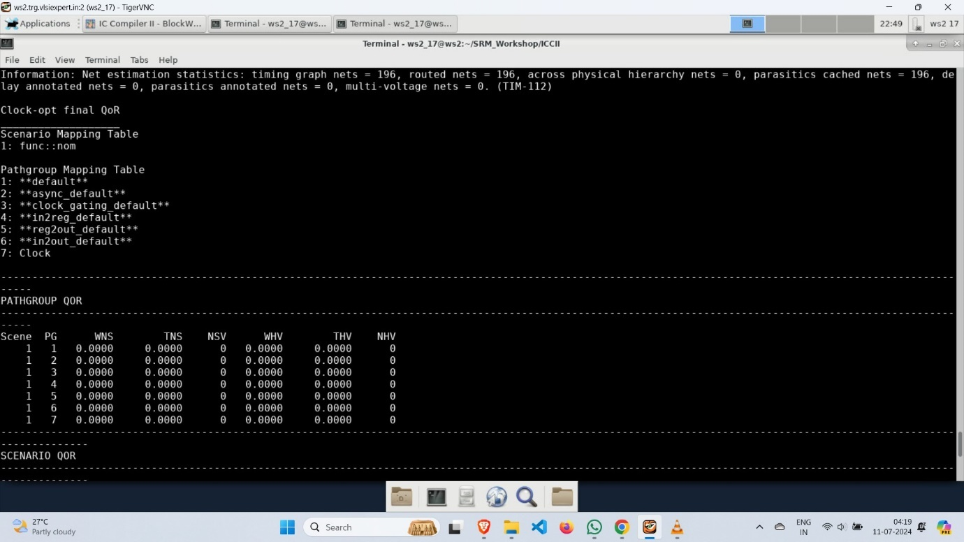

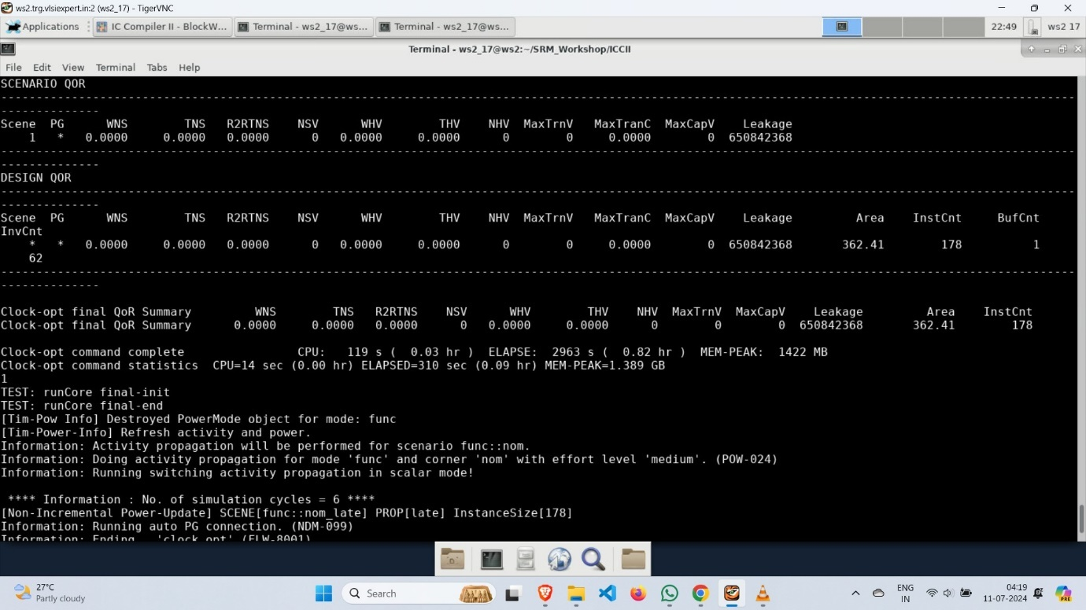

* report_design

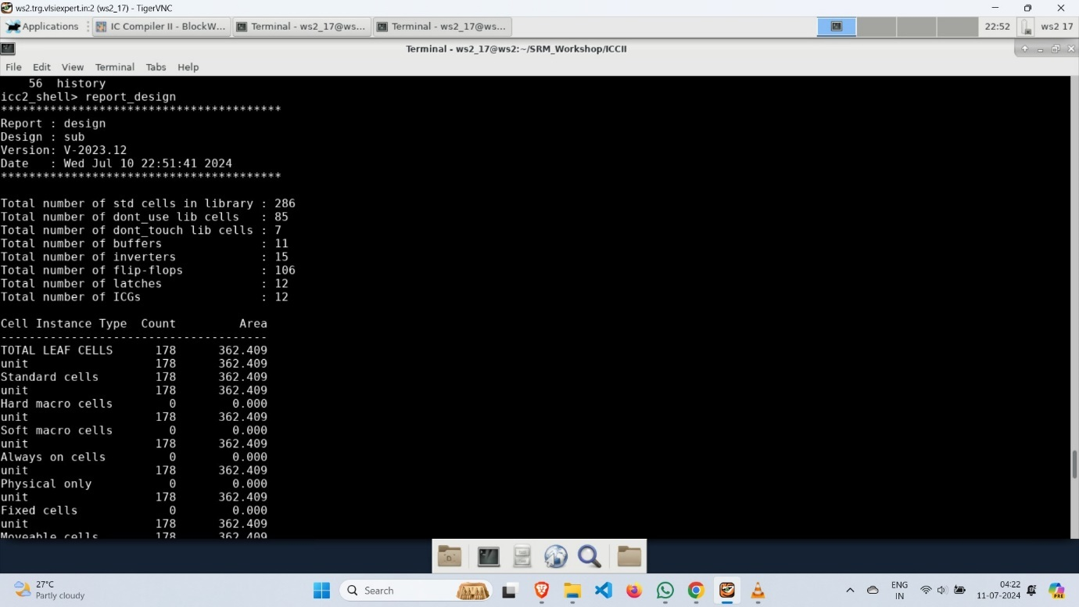

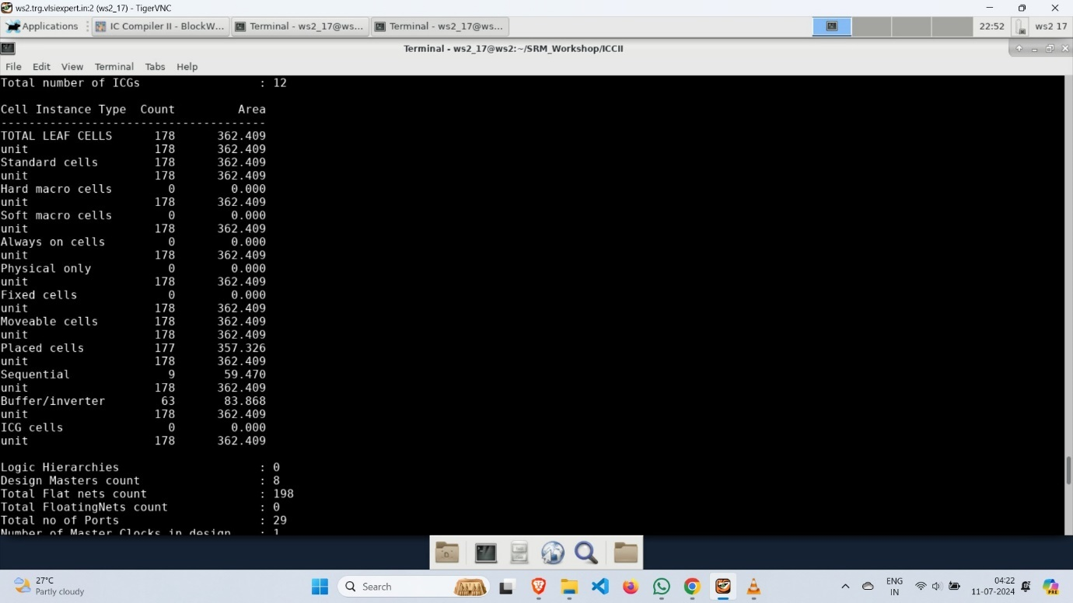

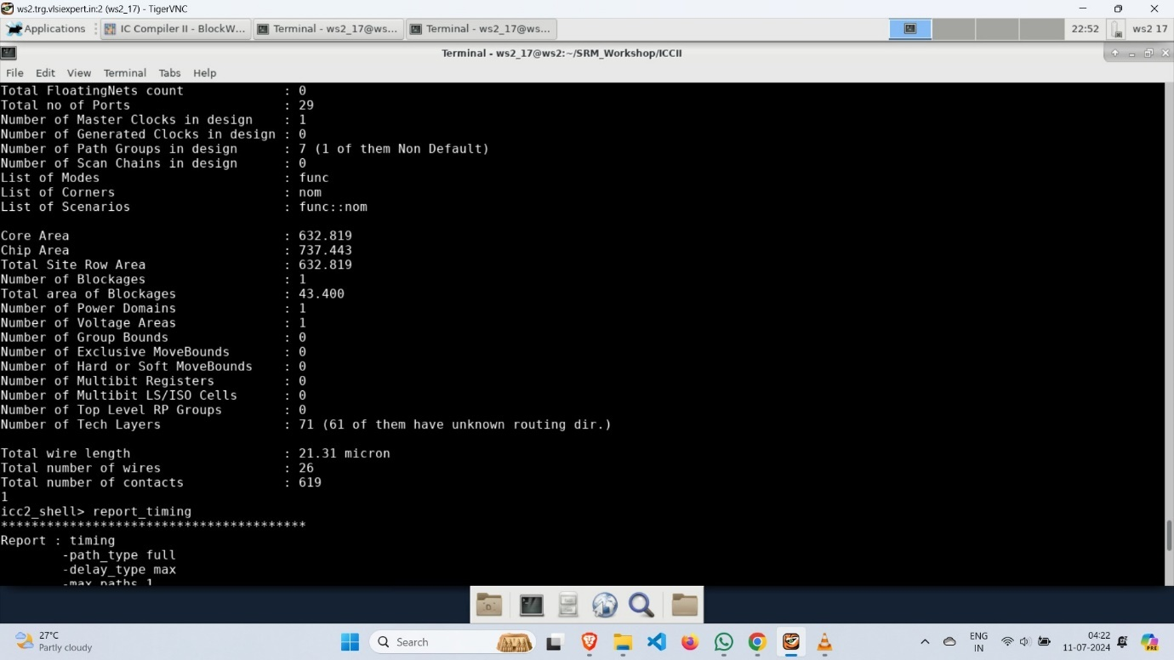

* report_timing

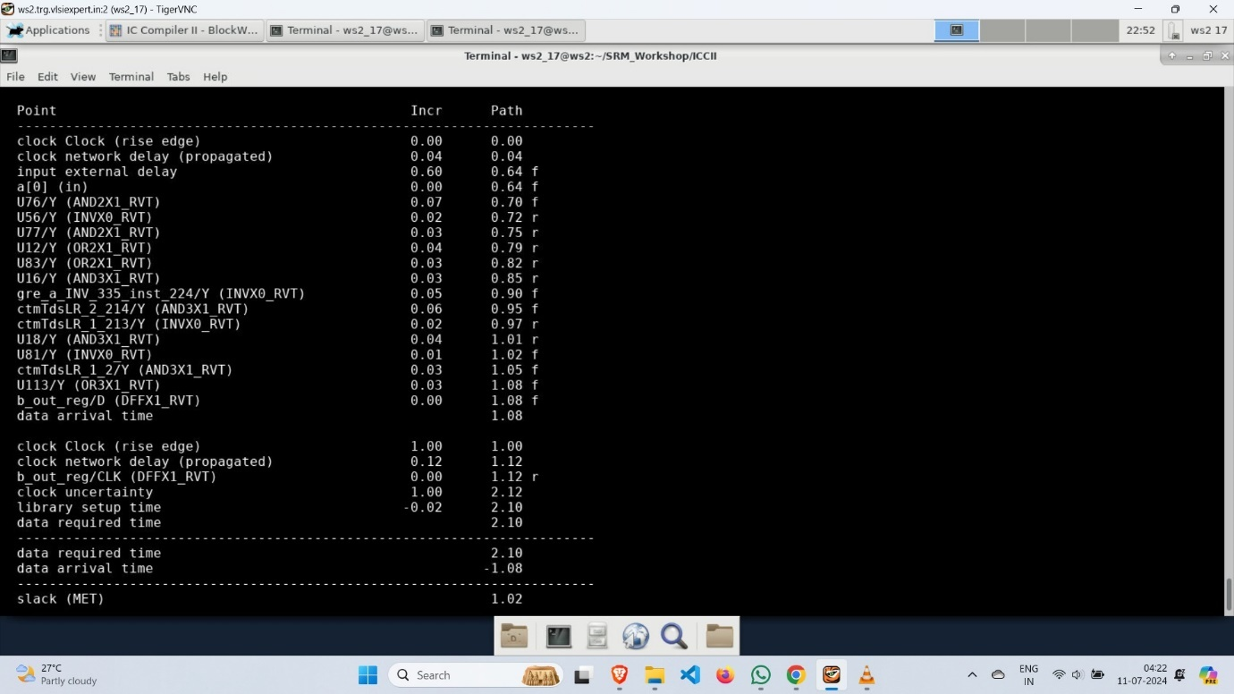

* Now, go to the IC Compiler II to see the output of the CTS.

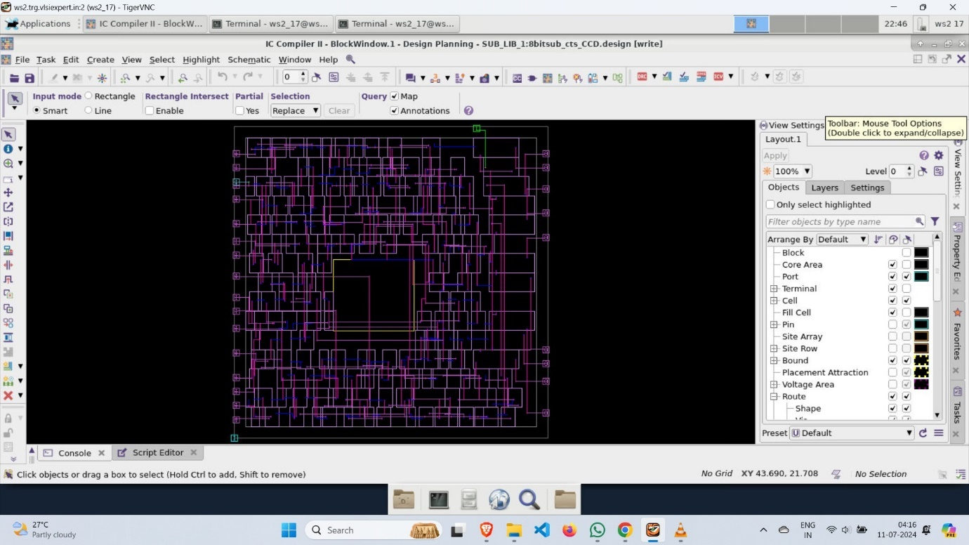

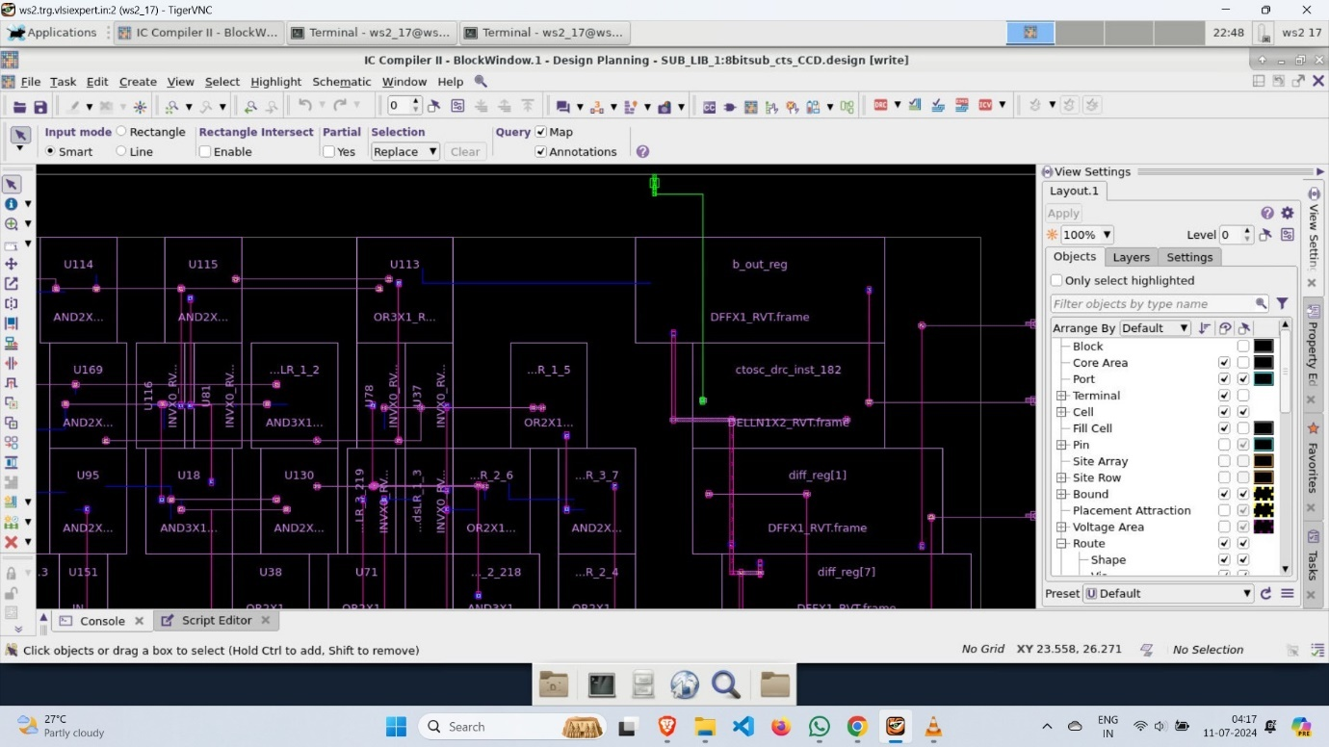

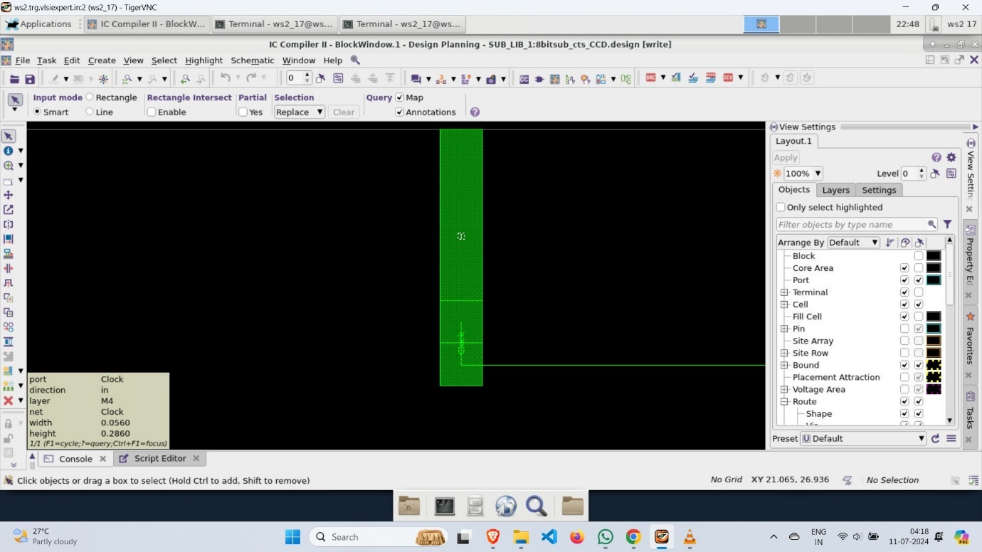

**Routing**

* Routing involves creating the physical connections between placed components on a chip, ensuring signal integrity and meeting design constraints. This step translates the logical design into precise geometric patterns for manufacturing.
* After the completion of CTS execute the all commands of the routing in icc2_shell.
* report_design

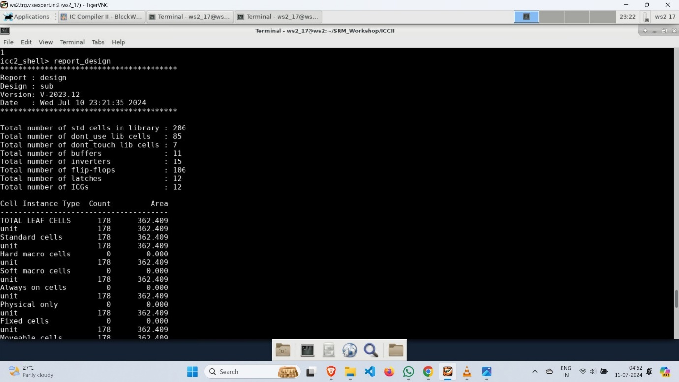

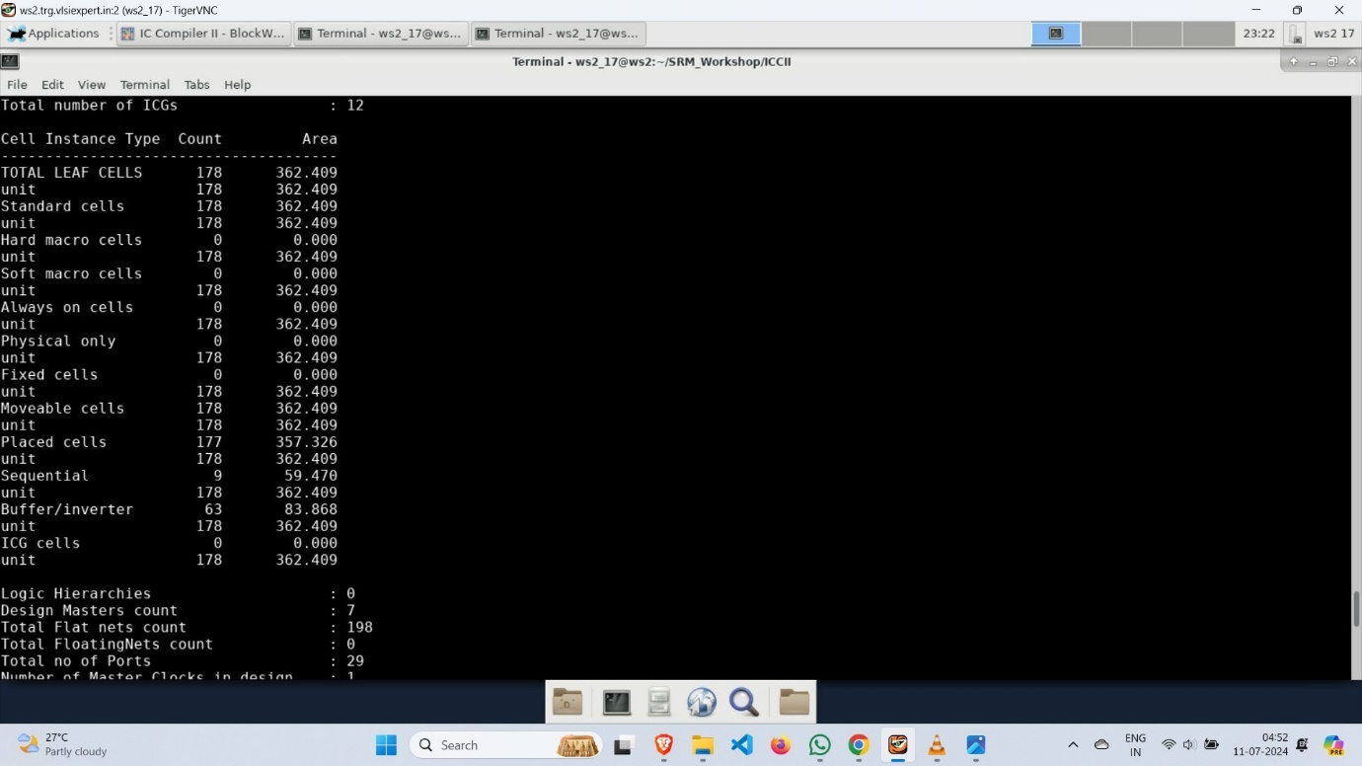

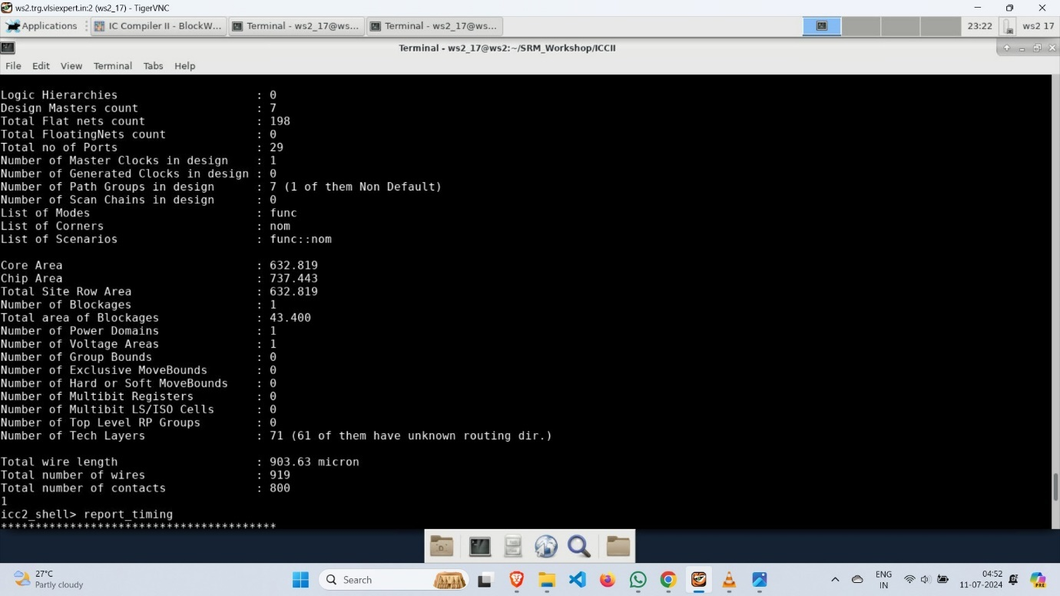

* report_timing

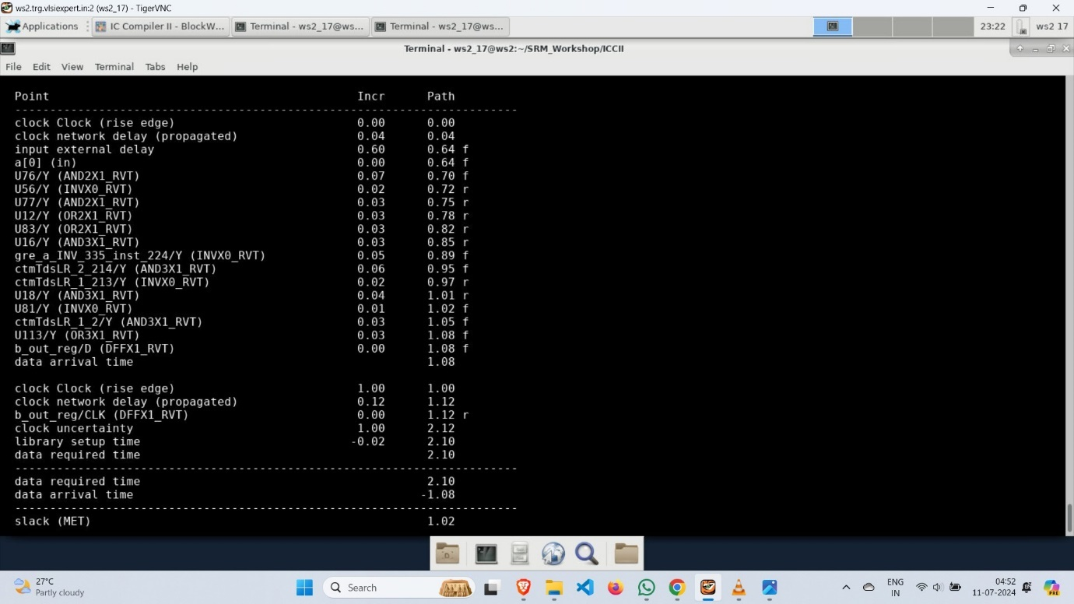

* Now, go to the IC compiler II to see different diagrams(outputs) on selecting different Metal Layers such as M1, M2 and so on.

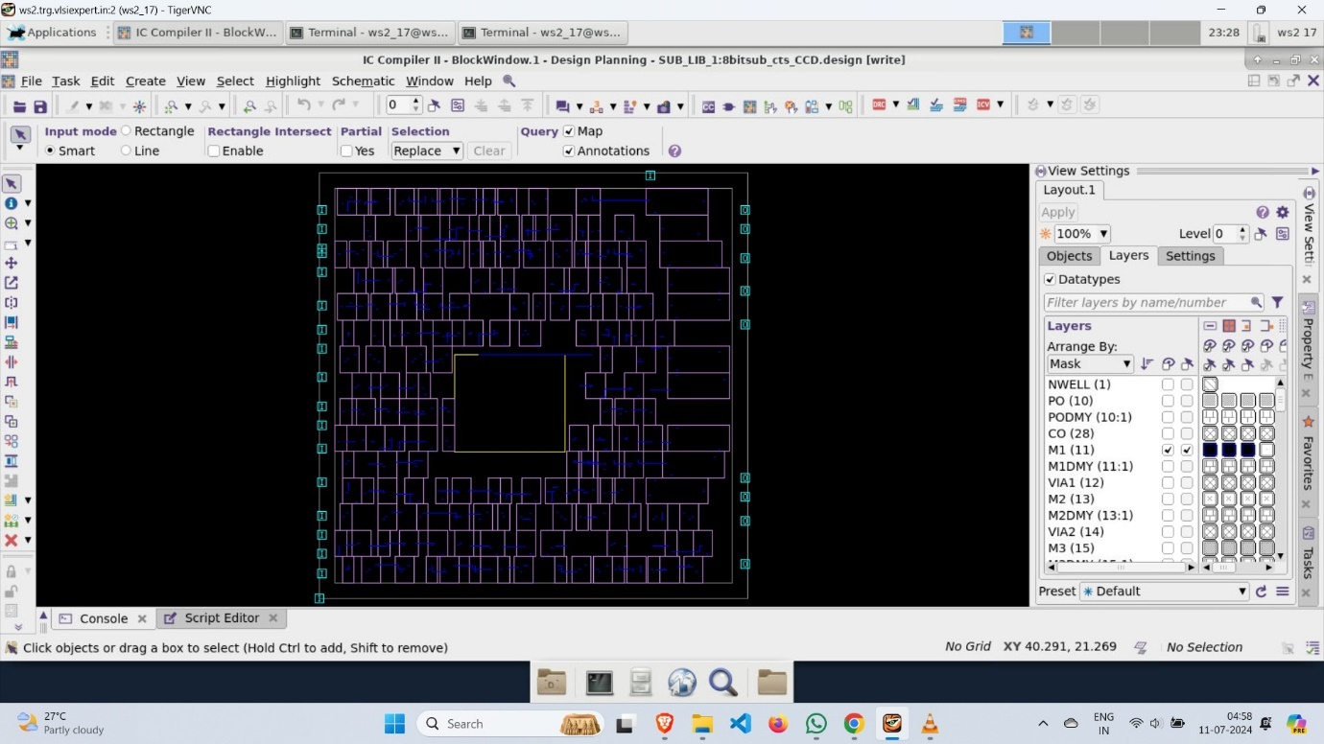

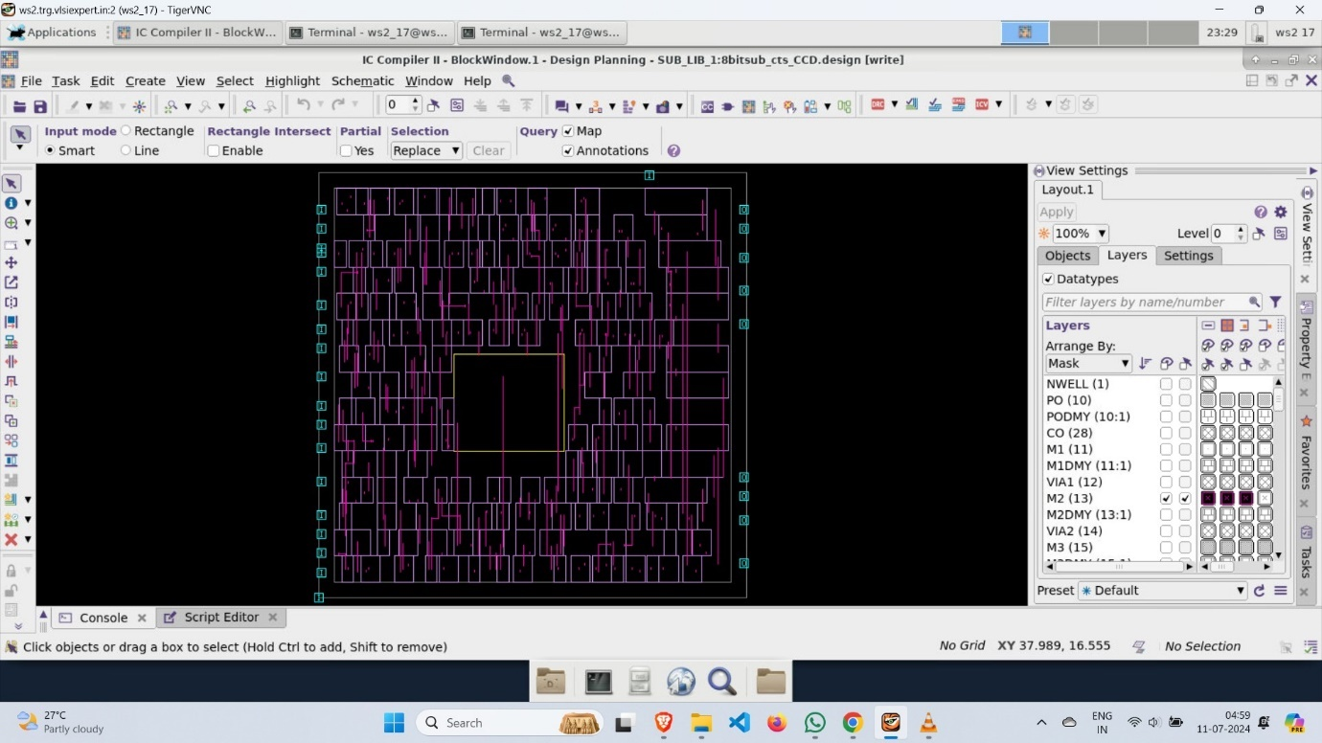

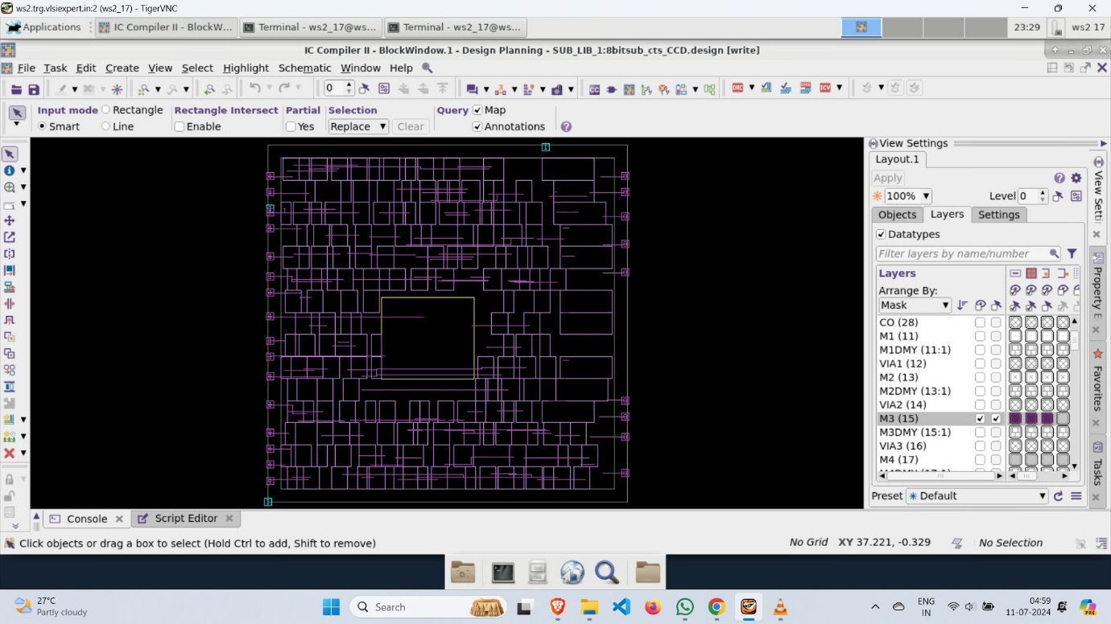

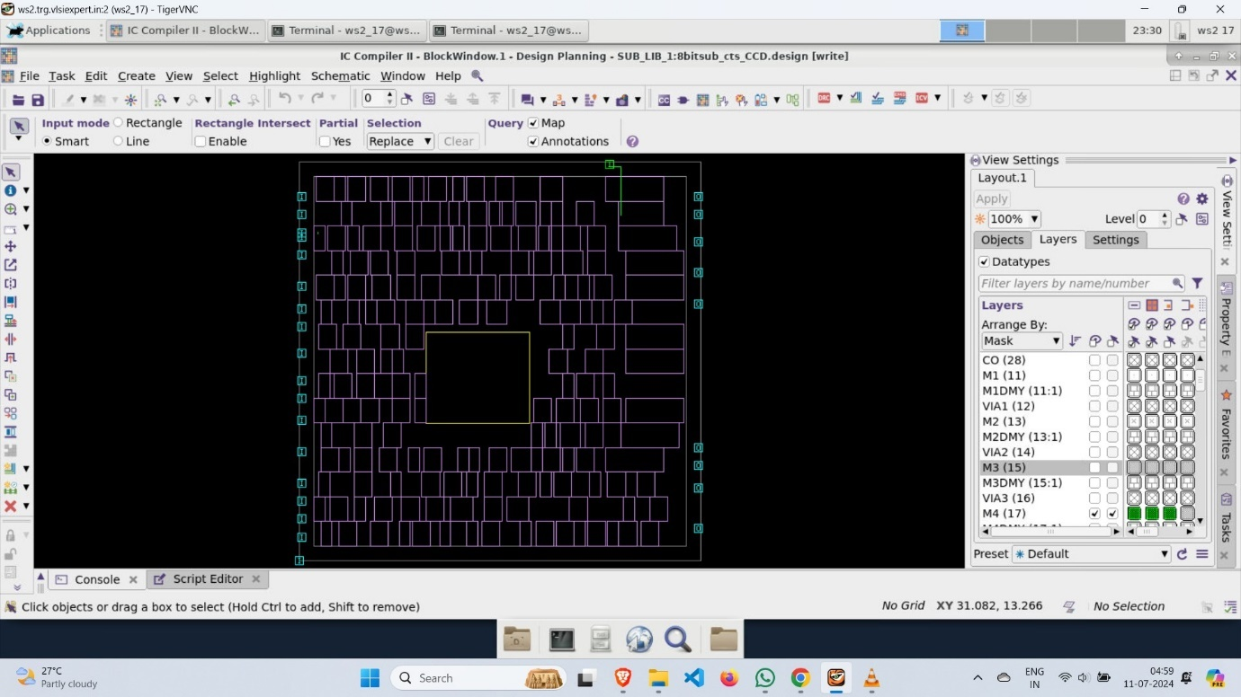

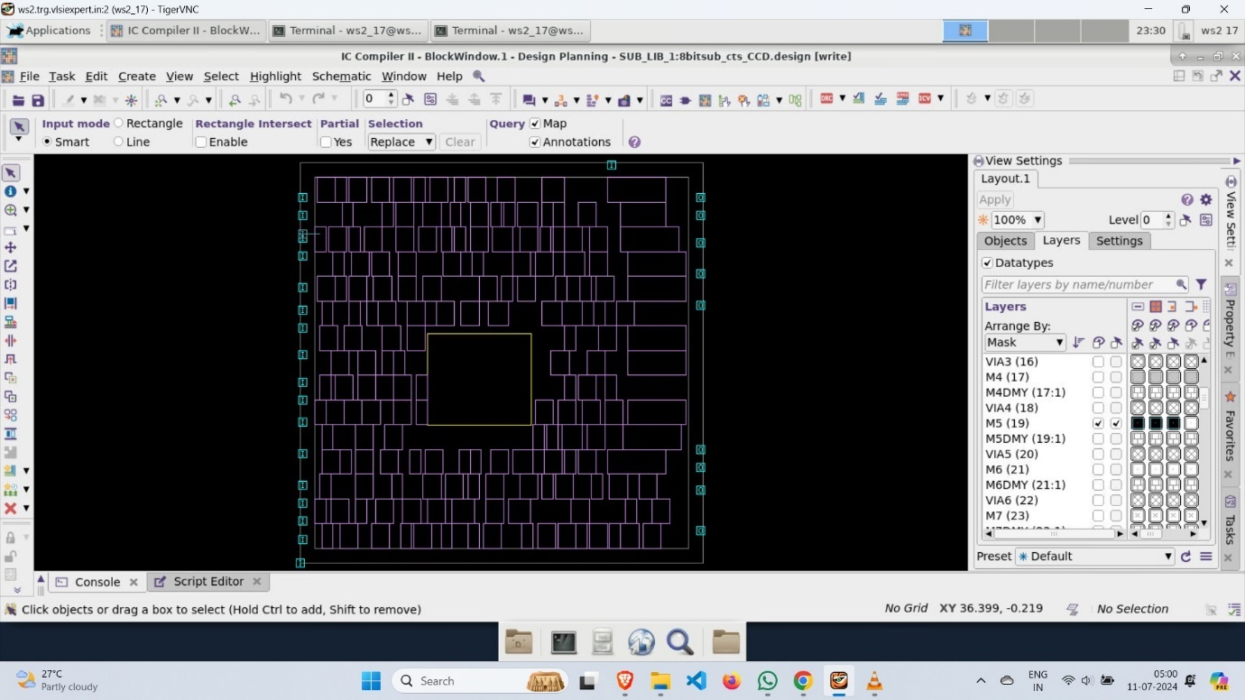

* If you want to see the different files such as “sub.routed.v”, “sub.routed.sdc” and “sub.spef” then go to results directory in the ICCII directory.

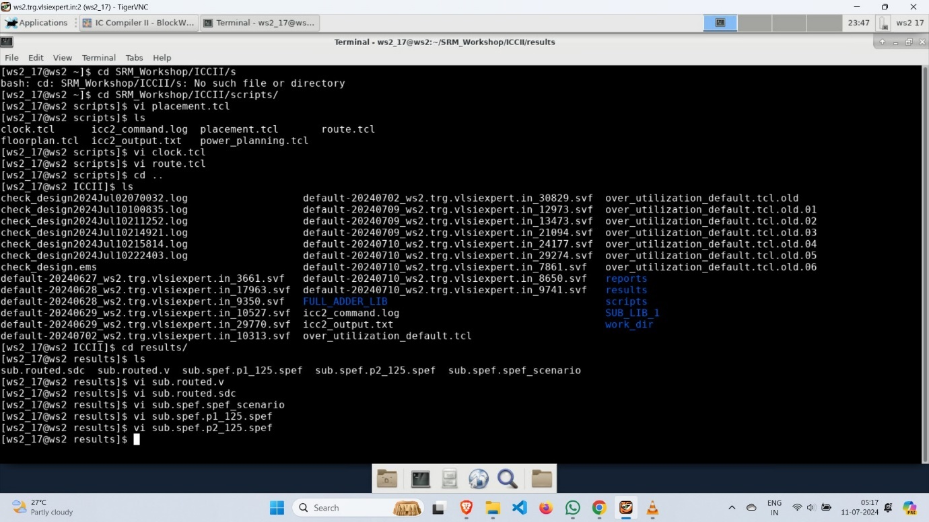

* sub.routed.v

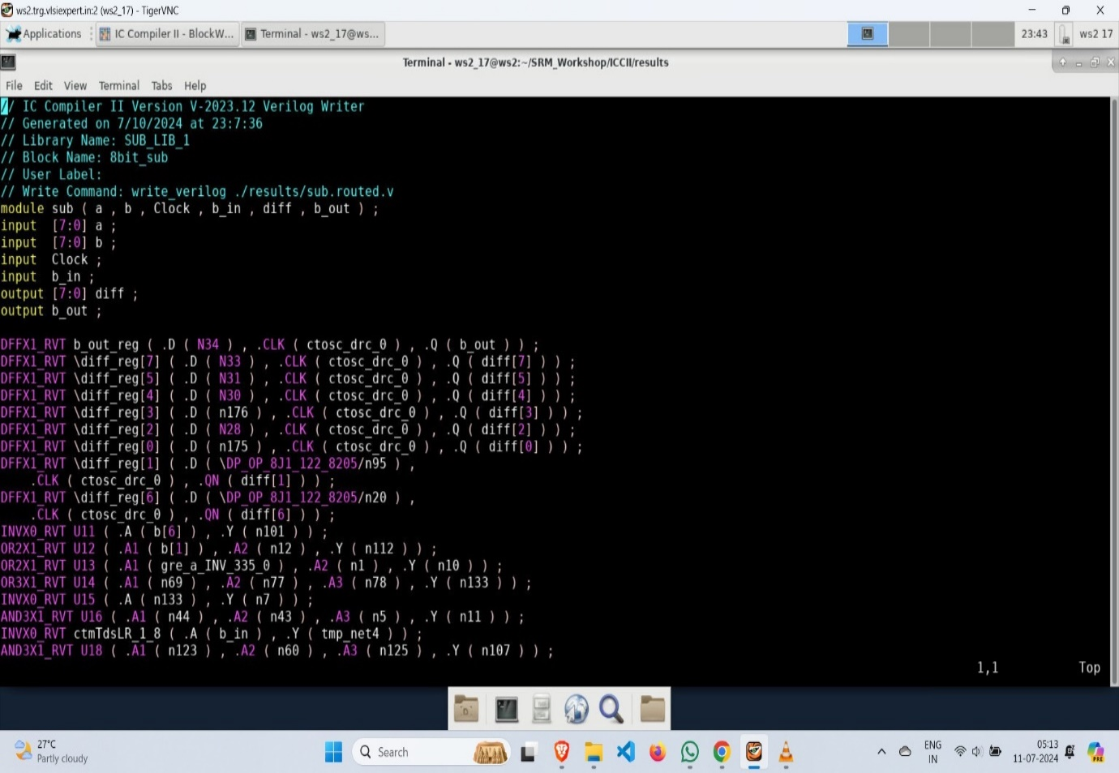

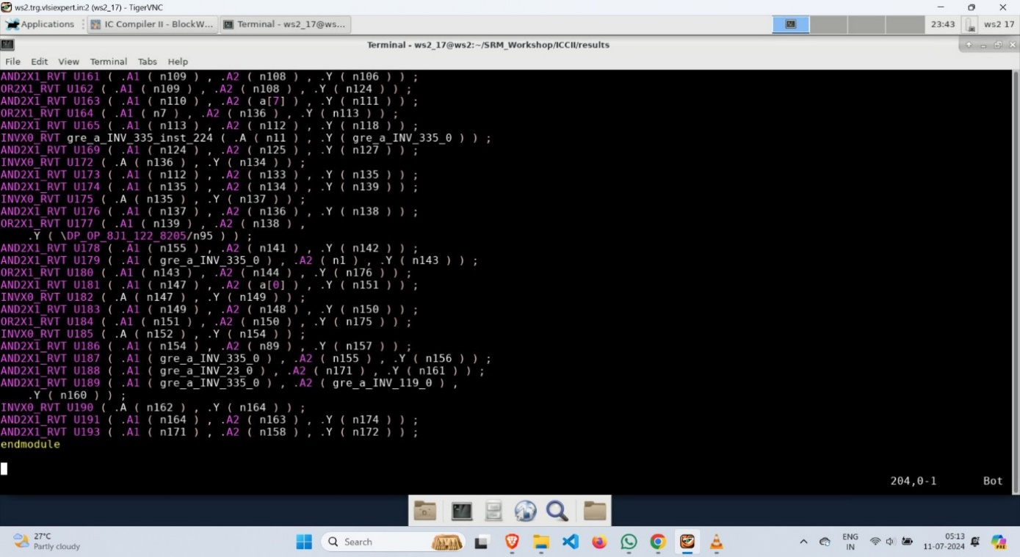

* sub.routed.sdc

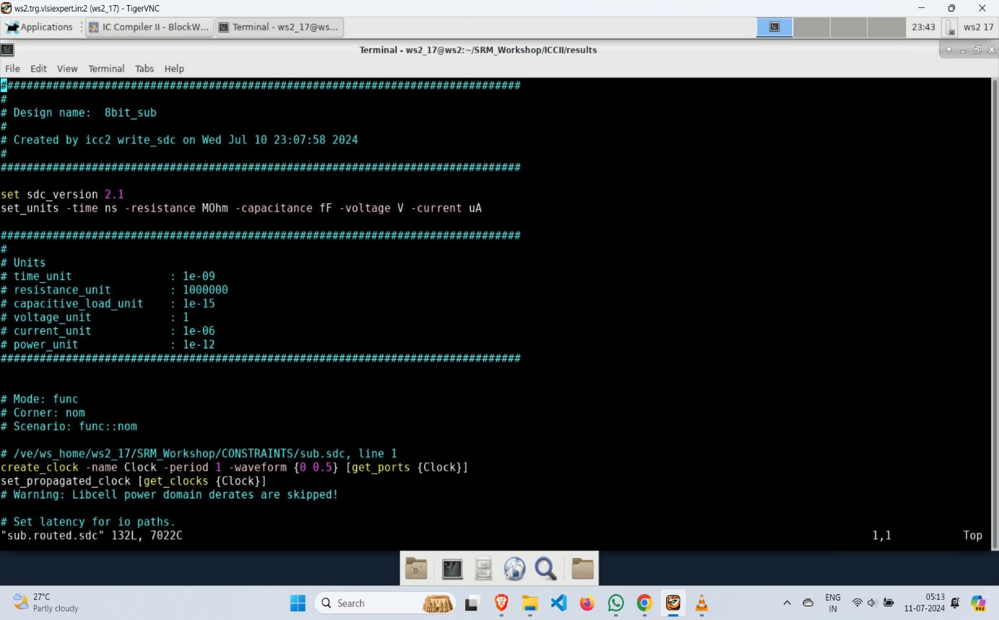

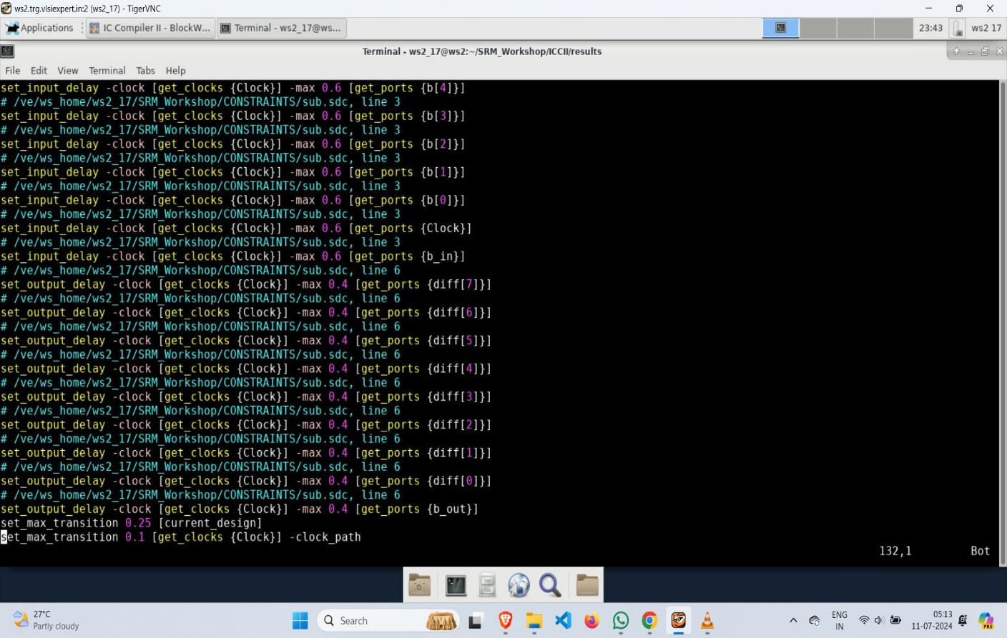

* sub.spef p1 and p2

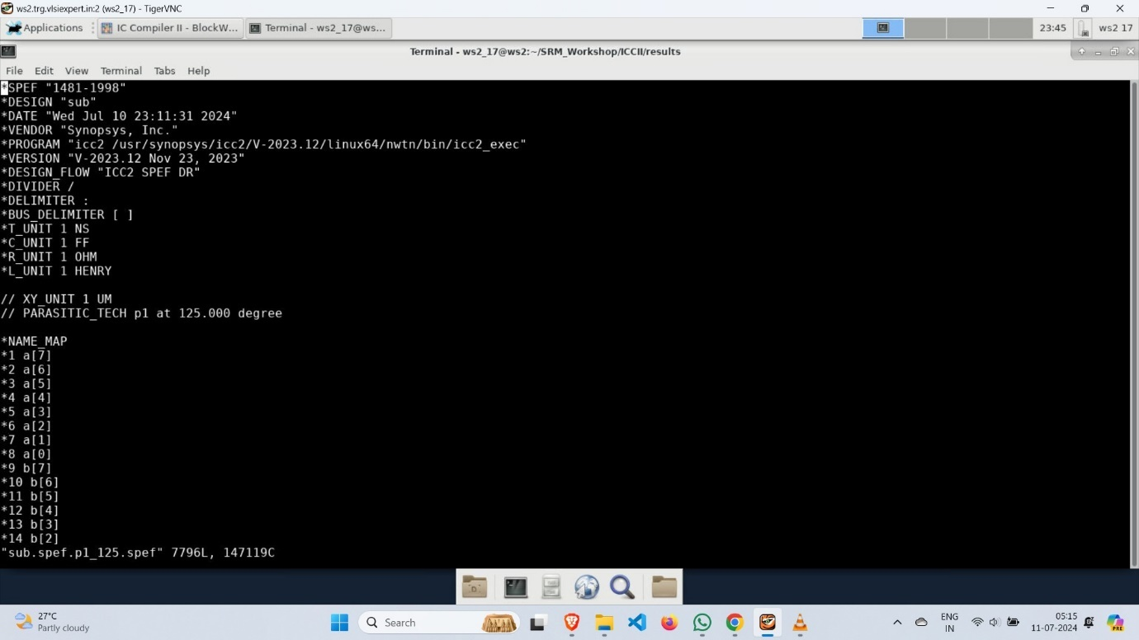

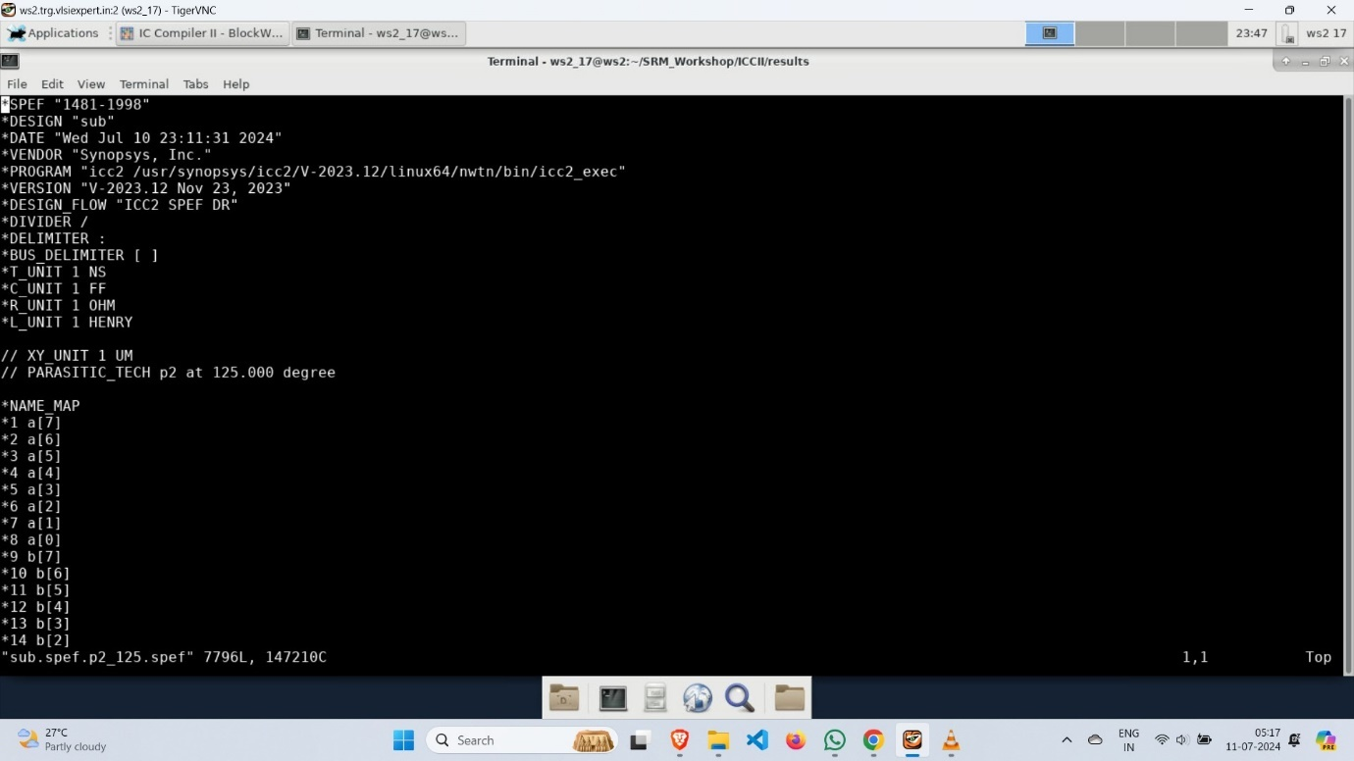

**Timing Analysis**

* Timing analysis involves verifying that all timing constraints are met to ensure the circuit functions correctly at the desired clock speed. It checks setup and hold times, clock skews, and propagation delays to ensure proper data synchronization and avoid timing violations.
* Invoke the pt_shell in PT directory of SRM_Workshop directory and execute all command lines in pt_shell.

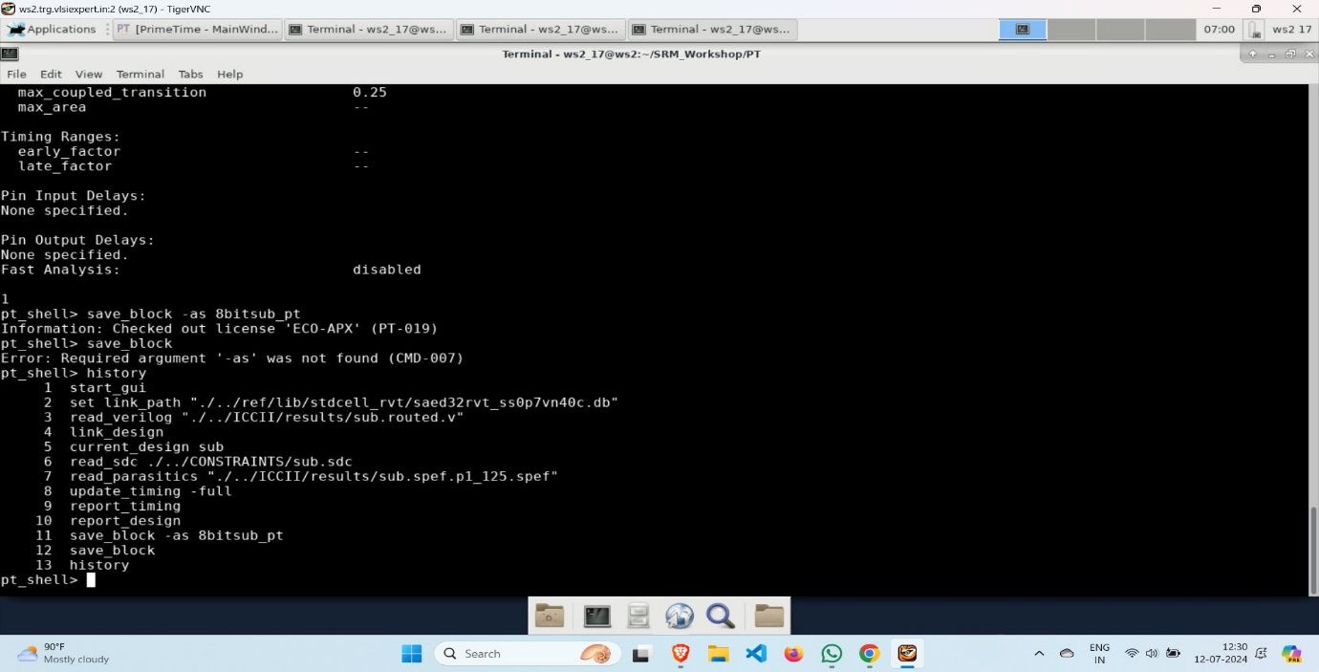

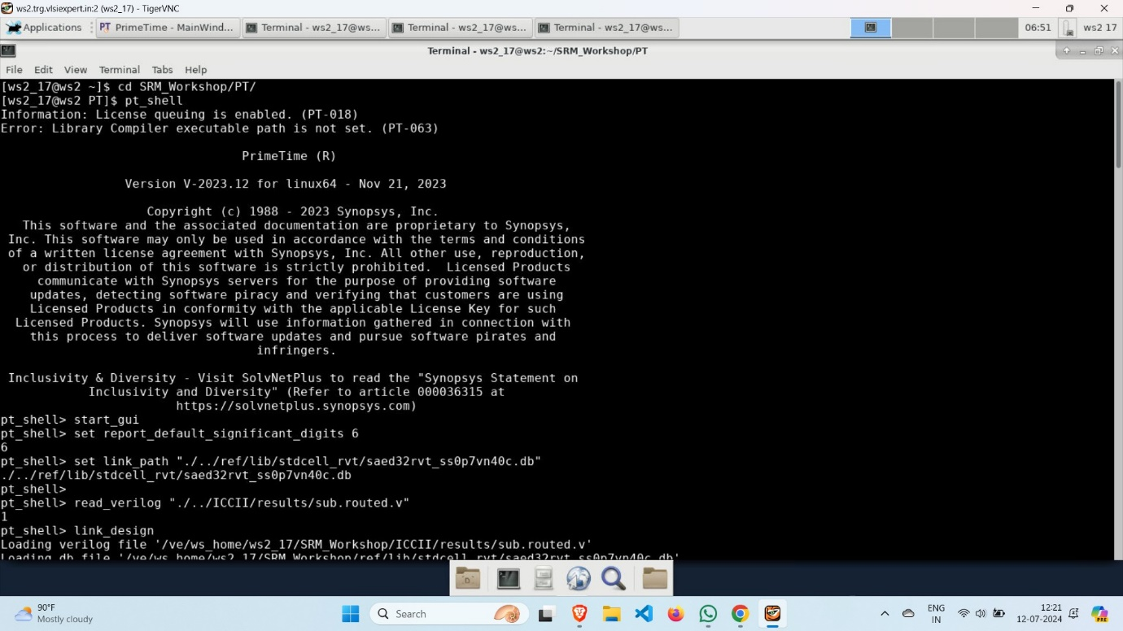

* Output

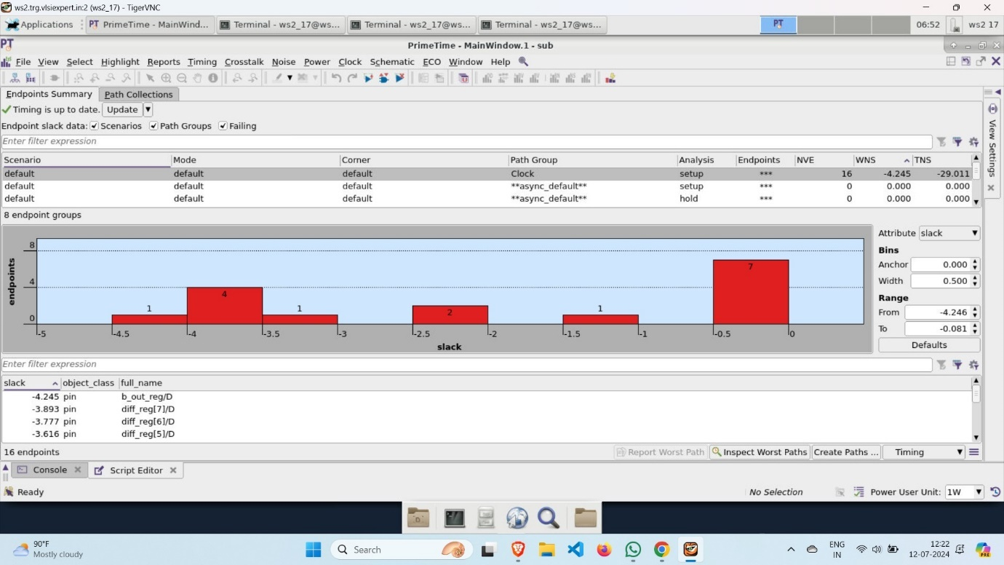

* report_design

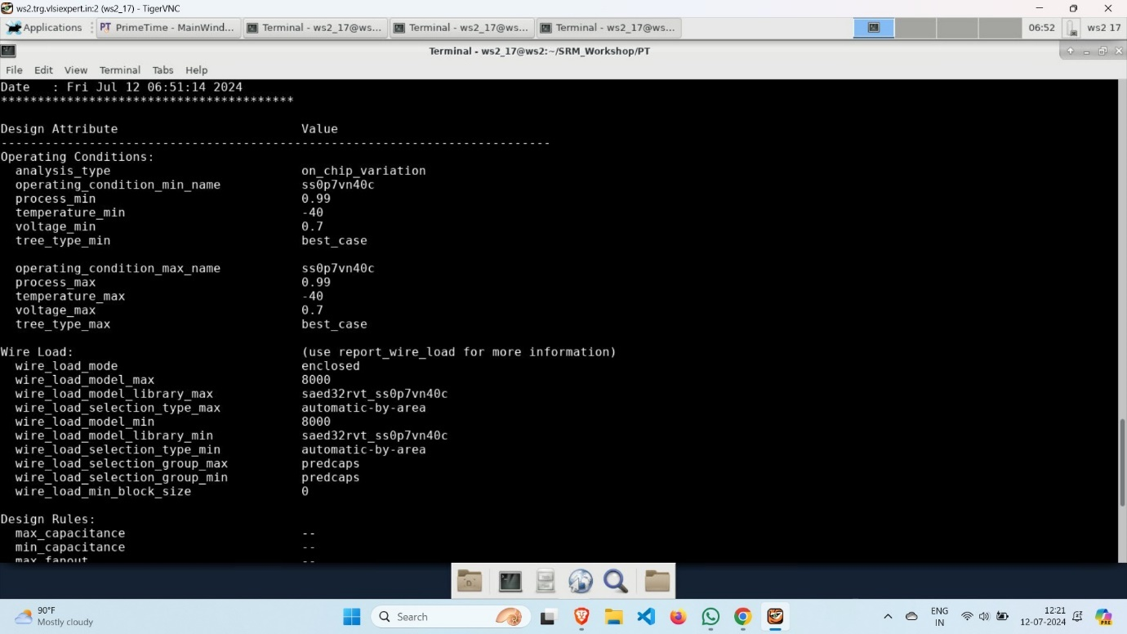

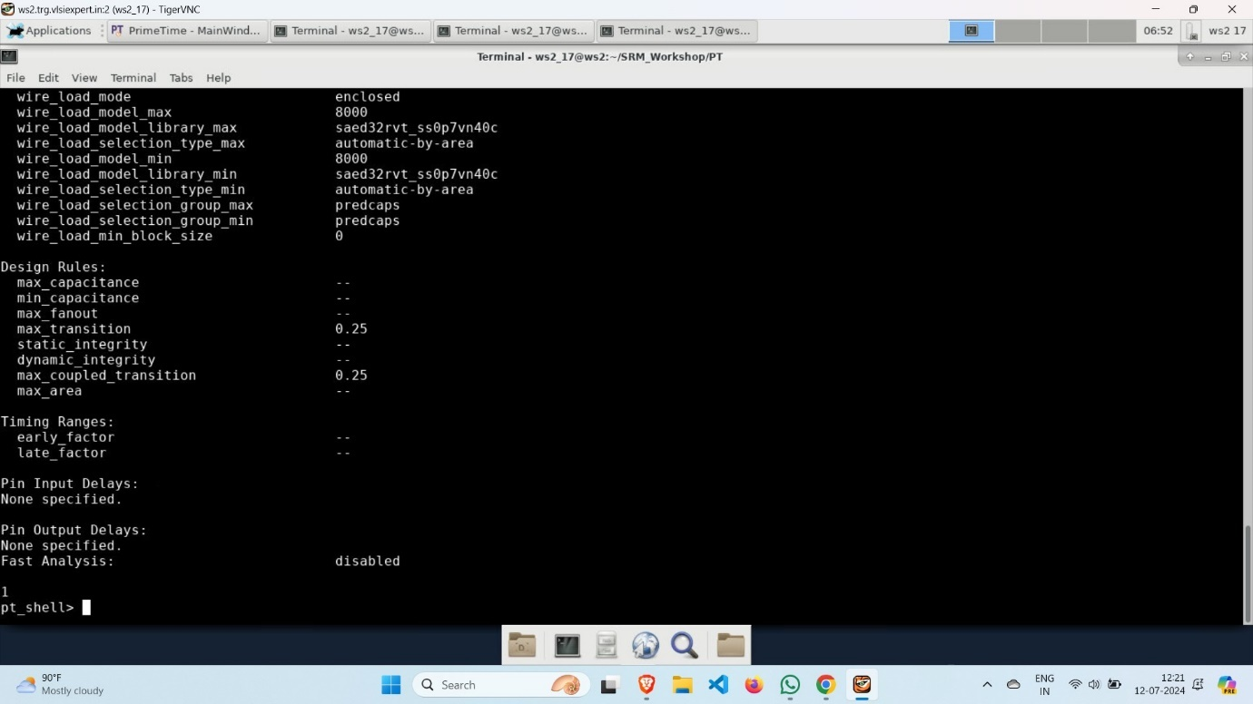

* report_timing

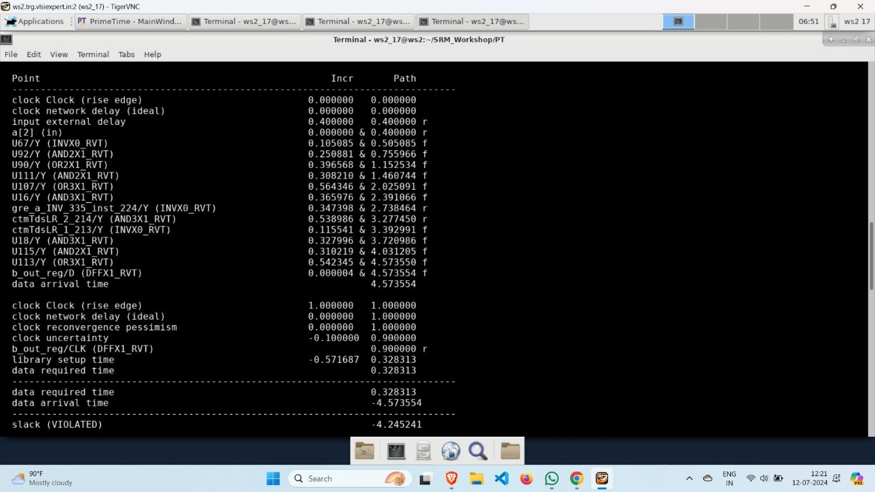

* We can see slack is violated then we have to fix it by going to sub.sdc file in CONSTRAINTS directory.

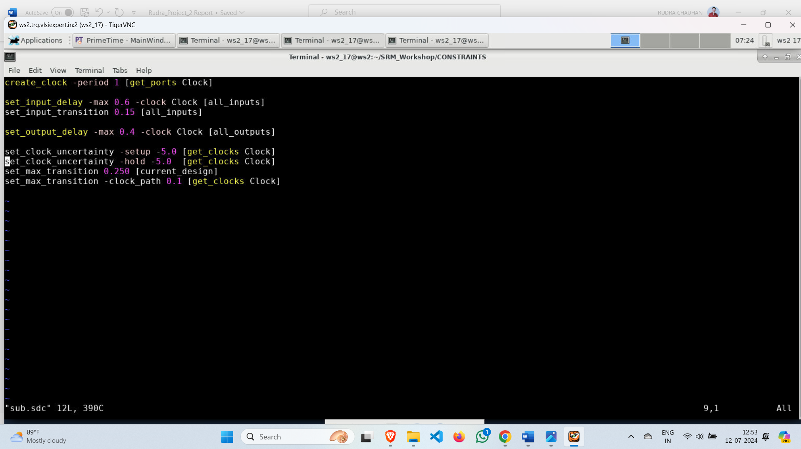

After fixing slack

* report_timing

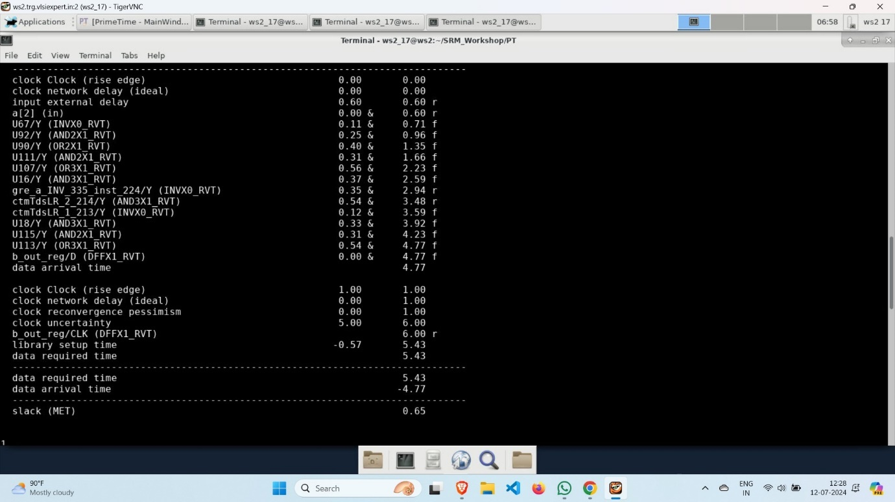

* report_design

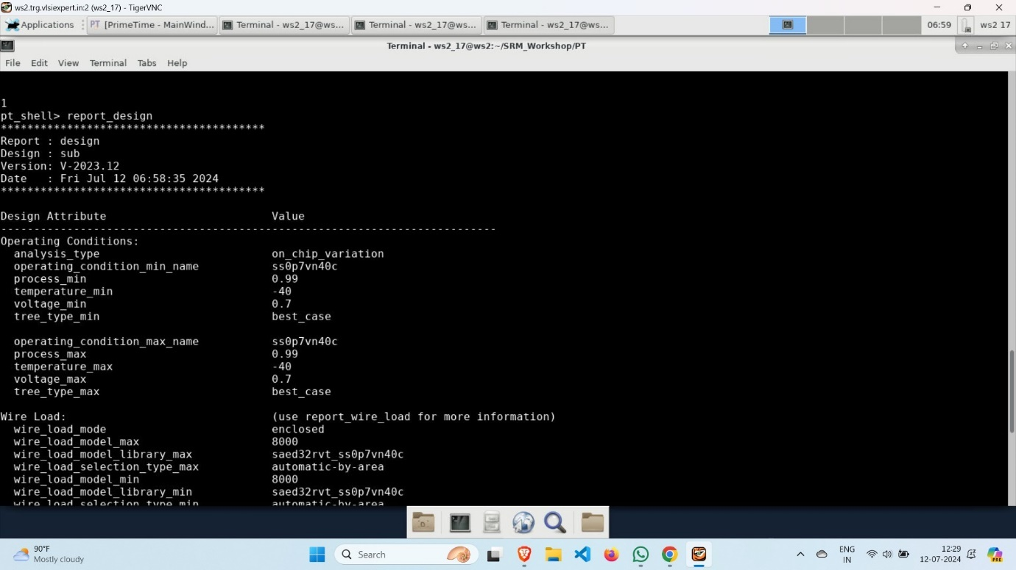

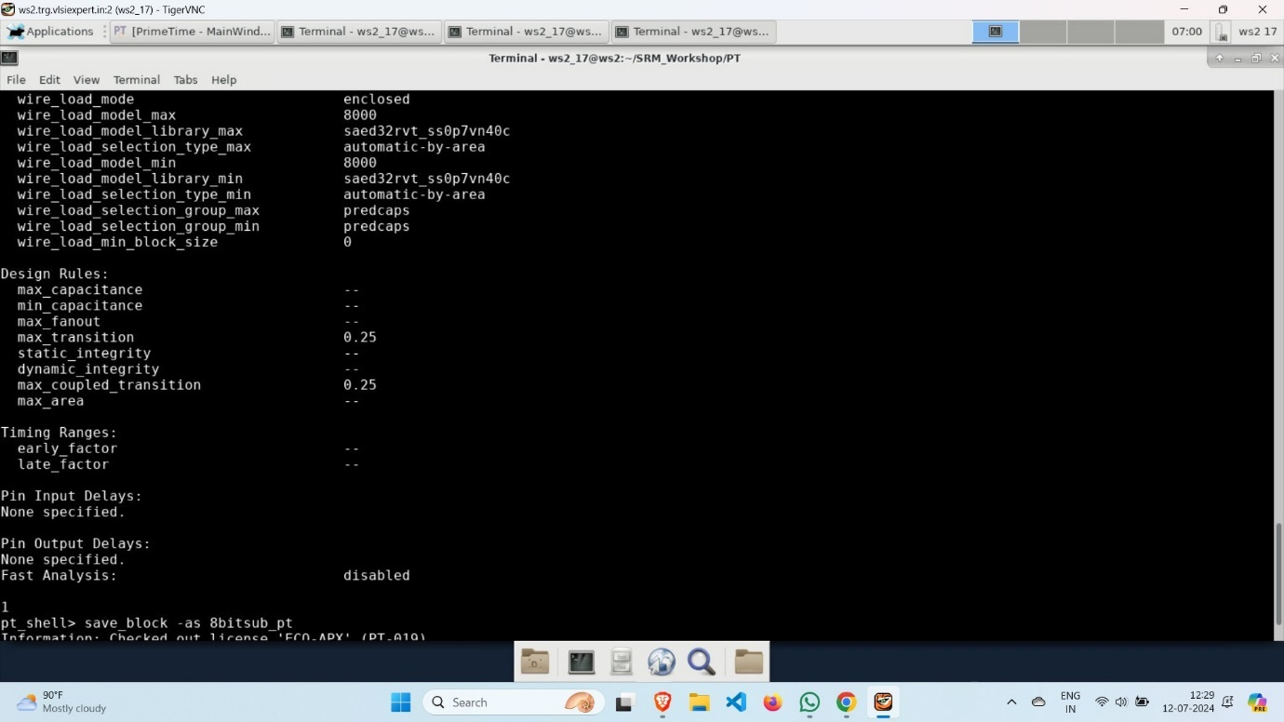

**Conclusion**

The 8-bit subtractor using Synopsys tools reveals that the design meets the specified performance metrics for timing, area, and power consumption. The synthesis and place-and-route processes were completed successfully, with the critical path timing within acceptable limits, ensuring no setup or hold time violations. The layout optimization achieved efficient utilization of silicon area, and power analysis indicated minimal dynamic and static power dissipation. Overall, the design is robust, reliable, and ready for further verification and potential fabrication, meeting the desired operational criteria and constraints.